The role of volunteer sampling and source identification in development of a bacterial TMDL for Pine Creek
Jeanne VanBriesen, Mitchell Small, David Dzombak, and Kelvin Gregory
Center for Water Quality in Urban Environmental Systems (Water QUEST) Carnegie Mellon University

a. Narrative Description of the Project (brief answers to the following questions)
i. What was the project suppose to accomplish?
The project was designed to add value to the Pine Creek Watershed Bacterial Monitoring Project in 2007, which used volunteers for sampling. Specifically, we wanted to evaluate (1) if sampling frequency would affect impairment classification, (2) if the suggested load reduction in the TMDL process was sensitive to sampling frequency, and (3) if post-restoration updating of the TMDL could be accomplished with data taken for compliance. Further we sought to determine if population diversity information beyond indicator organisms would assist with evaluation of sources of contamination in the watershed, and we wanted to evaluate the use of volunteer monitoring data for regulatory decision-making.

- What you actually did and how it differs from your plan?
Water samples were collected in collaboration with PaDEP and volunteers in the Pine Creek Watershed in the summer of 2007. These samples were analyzed by Alcosan for fecal coliform and E.coli. We also analyzed a subset of these samples for E.coli in our laboratory at Carnegie Mellon. We used these data to evaluate the importance of sampling frequency and the suitability of volunteer monitoring data. However, development of a model of Pine Creek Watershed by TetraTech was delayed. This made it impossible to evaluate the suggested load reductions in the TMDL process and the post-restoration data needs. Water samples taken concurrent with those for indicator organism analysis were analyzed with denaturing gradient gel electrophoresis (DGGE) to evaluate diversity and look for diversity patterns in different areas of the watershed and under different weather conditions.

iii. What were your successes and reasons for your success?
In collaboration with Pa DEP and watershed volunteers, we successfully analyzed the watershed for compliance with the FC and E.coli standards. Shown in Figure 1 are the results for E.coli for the recreational season. The x-axis shows the location of the sample in miles from the mouth of Pine Creek. The y axis shows the geometric mean of five samples within a month in the season. Multiple results are shown as the weekly sampling from May-Oct resulted in multiple five week windows that could represent the water quality. Significant variability is shown; however, all locations exceed the recreational standard of 125 CFU/100ml during most of the recreational season. Figure 2 shows the correlation between the two indicator organisms measured (E.coli and fecal coliform). This figure shows a strong correlation between these two indicator organisms for this watershed (the shown trendline is a power relationship with an R² of 0.9). Wet weather in both the upper and lower watershed produced higher levels of both indicator organisms (shown in black). Dry weather overall showed lower levels (shown in pink). The upper (squares) and lower (triangles) watershed areas did not show significant differences in correlation of these indicator measurements.

We successfully evaluated the DGGE results for various areas in the watershed and for different weather conditions. Raw DGGE gels with amplification of bacterial 16s rDNA showed banding patterns that were qualitatively different in the upper (sites 19, 22, 23), middle (sites 13, 15, 17) and lower (sites 2,5,7) parts of the watershed as well as different during wet and dry weather, suggesting wet weather events in the watershed (combined sewer overflows or stormwater runoff) affect bacterial population diversity in ways that can be visualized with DGGE. Statistical clustering analyses enables us to quantify these observations. Analyzing results during a rainfall event (6/20/2007) shows a clear distinction between sites in where there are no combined or sanitary sewer overflow points (19, 22, 23 and 13), and those in the lower watershed where there are multiple CSO and SSO input points (2,5,8,11). Thus, the DGGE patterns can be interpreted to identify CSO event signatures in the total bacterial population of a sample (Figure 3). Further results show the DGGE banding patterns are stable with downstream travel in this watershed. For example, sites 22, 19, 7 and 2 are along the main stem of Pine Creek. Their DGGE signatures cluster strongly during dry weather across multiple sampling days. During wet weather, this changes, with upper watershed sites (22 and 19) clustering and lower water shed sites diverging (7 and 2). There are 5 CSO outfalls and 1 SSO outfall in this area of the watershed. In dry weather, the bacterial populations are stable for the full run on this creek but in wet weather, the bacterial load from the CSO events significantly shifts the population and this signal is clearly apparent through the cluster analysis (data not shown).

Figure 1: Indicator bacteria concentrations for the RECREATIONAL (May - Sept.) season longitudinally along Pine Creek Watershed.

Figure 2: Log-log scatterplot of E. coli vs. fecal coliform for WET (black) and DRY (pink) days during the RECREATIONAL season.

Figure 3. Clustering analysis for samples collected on June 20th , 2007

We successfully evaluated the sensitivity of the impairment classification to sampling frequency. A waterbody’s classification as impaired is sensitive to the sampling frequency only if that waterbody has variability in the indicator bacterial levels above and below the regulatory limit. Out of the 25 sampling sites, 6 sites consistently have indicator bacterial concentrations above the regulatory limit for all weather conditions. For these sites, a decrease or increase in sampling frequency is unlikely to change the status of impairment. We confirmed this through statistical analysis of the relationship between flow and concentration and evaluation of the effects of missing data. For sites where results were more variable, impairment classification may be affected by sampling frequency.

Site 18, Willow Run, has a positive relationship between flow and bacterial concentration. Figure 4 shows that as flow increases in the tributary, the concentration also increases; this is common to the up-stream tributaries and to the portion of Pine Creek in the lower watershed as illustrated in Figure 1 (Little Pine Creek shows the opposite relationship). To consider the possible missing samples, the CDF of flow from USGS site 03049800 is used since no USGS gauge is located within Willow Run and the slopes and watershed sizes are comparable. Figure 5 shows for site 18 that the samples collected from one recreational season only represent 50% of the long-term hourly average flow record (high and low flow ranges were not represented in the sampling). To account for effect of these missing samples on the classification of the stream, the linear regression between flow and concentration shown in Figure 5 is used to predict the concentration for the missing flow conditions. By doing this, the distribution of concentration in the stream can be calculated by drawing random samples of flow from the flow CDF and assigning a concentration to each flow. Figure 6 shows the resulting concentration CDF for site 18. According to the predicted CDF, the in-stream concentration is above the standard 90.0% of the time during the recreational season. In contrast, the samples for site 18 indicate that the in-stream concentration is above the recreational standard only 27.0% of the time. Therefore, the samples alone give the impression that the waterbody is better than a long-term record would suggest. This discrepancy suggests that sampling beyond one recreational season or more often than weekly is important in order to capture more of the possible conditions in the stream.
Figure 4. Scatterplot of Flow and Fecal Coliform Concentration for Site 18, Willow Run. Like many up-stream tributaries, the samples collected at site 18 over the recreational season have fecal coliform concentrations above and below the regulatory limit of 200 cfu/100ml (dashed line).
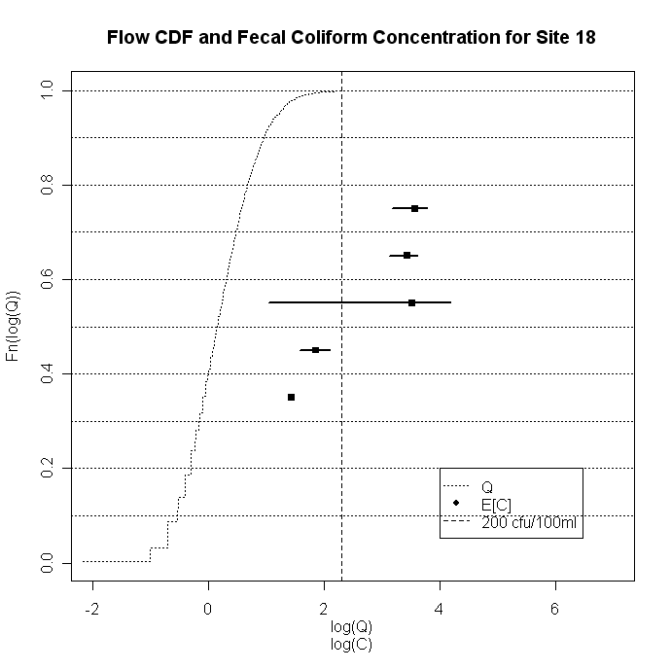
Figure 5. Cumulative Distribution Function of Flow for the Recreational Season with Observed In-Stream Average Concentration for Site 18. The figure displays the CDF for flow along with the average observed in-stream bacterial concentration for the recreational season. The x-axis measures flow, log₁₀(Q) (cfs), and in-stream bacterial concentration, log₁₀(C) (cfu/100ml), and the y-axis measures density values. The black bars show the minimum and maximum observed concentrations in each percentile.
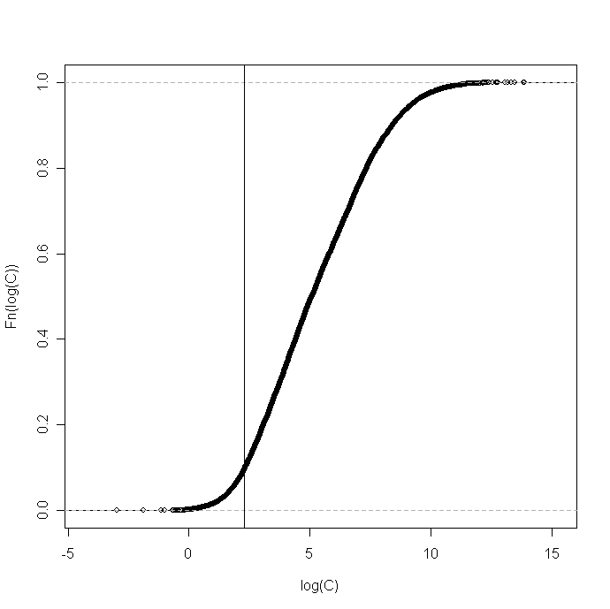
Figure 6. Cumulative Distribution Function of Concentration for the Recreational Season for Site 18. The vertical line represents the limit set by the recreational standard.

iv. What problems you encountered and how you dealt with them?
There were two related problems. Access to flow data was not possible during the project as USGS was still confirming their new gauges in the system. Further, and likely related to the limited flow data, TetraTech did not develop a model for the Pine Creek Watershed. This made it impossible to pursue certain aspects of the original plan. However, we were able to make significant progress in other areas. If additional funding can be secured, we will revisit the effect of flow on these population dynamics when the flow data and model are available.

v. How your work contributed to solutions to the original problem?
The problem was a lack of sufficient data about indicator organisms in the watershed and the value of extensive sampling. Our work showed significant value to population diversity analyses.

vi. What else needs to be done?
We are still analyzing data and will continue to do so throughout the next few months. We will also collect samples from specific physical sources in order to evaluate if DGGE patterns are source-specific as our environmental sampling on this project indicates. This will then lead to development of a molecular microbial DGGE-based method to quickly identify physical sources that are affecting water quality in a watershed.

vii. What are you plans for disseminating the results of your work?
We presented these results at the Water Environment Federation Collection Systems conference in May 2008 in Pittsburgh PA. There was significant interest from the audience, and we received positive feedback on our approach. We are working on a manuscript for submission to the ASCE Journal of Environmental Engineering on the molecular microbial analyses. We are working on another manuscript for submission to Water Research on the flow and concentration relationships that will be completed after flow data become available for the timeframe of the study. We are working on a manuscript related to spatial relationships in the indicator data for submission to the Journal of Environmental Informatics. We will also submit an abstract to the 3RWW Annual Sewer Conference (to be held in September 2008) and to the Ohio River Basin Consortia for Research and Education Conference (to be held in October 2008).

viii. How well did you spending align with your budget request?
Spending was aligned with the budget request. Supplies needed for DGGE and clone library generation were provided by Water QUEST (approximately $15K match), which enabled all funding provided by the sponsor to be used to support the graduate students working on the project. Funding was supplemented with a Steinbrenner Environmental Education and Research (SEER) fellowship for the graduate student working on the molecular microbial analysis ($30K), and with funding from the Pittsburgh Parks Conservancy (PPC) for the graduate student working on the flow duration curve analyses ($5K). An additional student working on GIS aspects of the system was funded through Water QUEST ($20K).

b. Summary in 50 word or less suitable for sharing with the public

Spatial and temporal analysis of bacterial loading is necessary to understand the sources of contamination and to determine a priority list for remediation efforts in a watershed. Our study of Pine Creek Watershed in Pennsylvania indicates portions of the watershed are impaired for contact recreation due to high levels of indicator organisms.

