PROTOCOL FOR RETROFITTING A DETENTION POND TO A WETLAND POND
The following narrative shows the seven general steps that any municipality can take to undergo a detention pond retrofit project. Within each of those general steps is the case-specific process that Shaler Township went about to select their potential detention pond to retrofit. These general and specific steps can be applied to any subsequent project undertaken by a municipality.
Wetlands have been documented to act as passive treatment BMP’s that improve water quality through the biological and physical removal of pollutants. Detention basins installed primarily to control the volume of stormwater are typically overdesigned due to the many assumptions and factors of safety within stormwater management formulas and models. As a result, a visual inspection of the majority of detention basins in your municipality after a significant rainfall event will show little to no detention. The low-flow pipe, or lowest invert on the riser structure, will be flowing nicely and discharging flow to the downstream receiving channel, but there is little benefit to the watershed. In fact, downstream channel erosion is prevalent in some detention basins, where none existed before.

Step 1 – Inventory all detention ponds
Shaler Township has 15 detention ponds in the Township. All 15 of the ponds have been plotted in the Geographic Information System (GIS). Each pond is also shown in relation to the closest tributary to the main creeks in Shaler Township – Little Pine Creek West, Little Pine Creek East, Pine Creek, and Girty’s Run. Here are each of the detention ponds, numbered to correspond with their designation on GIS, and the hydrological distance to the closest tributary or creek:
1 – Fox Meadows (underground) - 1400 ft from Little Pine Creek West
2 – Phyllis - 535 ft from tributary to LPC West
3 – Vilsack - 40 ft from LPC West
4 – Fernledge - 40 ft from tributary to Main Pine Creek
5 – Emerald - 30 ft from tributary to Main Pine Creek
6 – Spencer Woods - 865 ft from Main Pine Creek
7 – Spencer Ridge - 235 ft from tributary to Main Pine Creek
8 – Holly Ridge - 915 ft from Main Pine Creek
9 – Kimble - 30 ft from tributary to Main Pine Creek
10 – Westminster Place - 30 ft from tributary to Girty’s Run
11 – Marzolf - 200 ft from tributary to Girty’s Run
12 – Martha - 20 ft from tributary to Girty’s Run
13 – Fenway - 530 ft from tributary to Girty’s Run
14 – Seavey Highlands (underground) - 1350 ft from tributary to Girty’s Run
15 – Ridgeview Ct - 50 ft from tributary to Little Pine Creek East

Step 2 – Determine the relative size of each pond
Of the 15 ponds within Shaler Township’s boundaries, some are quite small and won’t have much impact on reducing flows from the first 1 inch of rain within the watershed. There are also two underground detention ponds that are not eligible candidates for this retrofit study (Fox Meadows and Seavey Highlands). At this point of the process, a broad spectrum “small”, “medium”, “large” can be assigned to the ponds.
1 – Fox Meadows (underground) – not eligible
2 – Phyllis - small
3 – Vilsack - small
4 – Fernledge - medium
5 – Emerald - large
6 – Spencer Woods - large
7 – Spencer Ridge - small
8 – Holly Ridge - medium
9 – Kimble - medium
10 – Westminster Place - medium
11 – Marzolf - small
12 – Martha - medium
13 – Fenway - small
14 – Seavey Highlands (underground) – not eligible
15 – Ridgeview Ct – large

It is best to keep the size designations rather simple, as each municipality’s contributory portion to a watershed is different. A pond may collect 5 acres of a drainage area, but be part of a 200 acre portion of a watershed, thus making its potential impact small. However, a pond could collect 5 acres of a drainage area and discharge into a 50 acre portion of a watershed and have a sizeable impact.

Step 3 – Establish selection criteria of pond to be retrofitted

Ruling out the underground detention ponds and the ponds classified as small leaves 8 ponds in the medium/large category. Access to the ponds is important, so the potential pond should not be in a remote location that would make construction difficult or ensconced in a neighborhood that would cause large-scale disruption. To that end, both Holly Ridge (remote) and Martha (proximity to neighborhood) were eliminated. The ability to bring construction equipment into the site, plus future post-construction monitoring activities, factors in to the selection process. However, the site can’t be too close to other homes for fear of mosquitoes being attracted to the proposed wetland and interfering with the quality of life for residents.
That leaves six ponds for consideration as a template for a detention pond retrofit: Fernledge, Emerald, Spencer Woods, Kimble, Westminster Place, and Ridgeview Court. Since this study is part of a Green Infrastructure project with Etna in the Pine Creek Watershed, we will rule out Westminster Place since it drains into the Girty’s Run watershed.
The two largest ponds of the five remaining are Spencer Woods (130’ by 140’ on the base) and Ridgeview Court (160’ by 80’ on the base). It is important that this project select a larger pond, if possible, not only for the demonstration aspect but also the impact that it may potentially have on the watershed. Both of these ponds have good access, but the Spencer Woods pond will be selected as the template because the potential aesthetic improvement will be greater. Even after a retrofit, the Ridgeview Court pond will still be a hole in the ground set over the steep rear hill from a development.
By process of elimination, Shaler Township selects Spencer Woods as the potential detention pond to retrofit. This pond has the volume capacity to impact change on the downstream watershed, is accessible for construction equipment, but not too close to other homes to generate fears of vectors such as mosquitoes and vermin.
In addition to size of pond and remoteness of pond, a third potential criteria could be impacts by the project on the downstream receiving channel. If the pond’s outfall is causing erosion downstream, a retrofit to reduce the “everyday” flows could greatly improve the occurrence of erosion and be a beneficial result of the project.

Step 4 – Determine the presence or absence of hydric soils
Hydric soils are soil types created under the sustained presence of ponded or flooded water. These hydric soils allowed for wetland plants (hydrophytic vegetation) to thrive properly. The continued presence of water allows the top tier of soils to become anaerobic in nature. The presence of hydric soils is indicative of a pond’s potential to become a functioning wetland.
Although the discussion of hydric soils is a very complex topic in itself, the basic takeaway for determining the presence of hydric soils is to examine a soil sample from the potential location to see if it has the tell-tale gray soil profile layer. By taking a soil spade to the prospective location and digging up a 12” diameter cylinder of soil, approximately 12-18” deep, the presence of hydric soils can be determined through examination.
After taking off the topsoil layer, check to see if the next layer down has gray colored soil. If so, this is showing that the soil profile has gone anaerobic, which is the indicator that wetland vegetation can survive. Additionally, examine the soil for the presence of redoximorphic reactions (otherwise known as “mottles”) in the soil. These red/brown flecks show that iron (Fe) and manganese (Mn) have chemically settled out of the soil profile due to saturated conditions.
The evaluator doesn’t have to be concerned if the soil profile is not as gray as an African elephant. In fact, there is a whole host of color matrices that a proper wetland evaluation must go through to determine the level of yellows/browns/reds in a soil. Rather, you just want to see the “mottles” within some type of anaerobic soil presence.
It is wise to consult the Allegheny County Soil Maps at the outset of the project, but wiser still to remember that they are a very broad-based outline of the potential soils you may encounter. It is imperative that a local municipality goes out and does their own soil samples at the potentially-retrofitted pond, whether done in-house or by a wetland consultant experienced in hydric soil analysis.
For the Spencer Woods detention pond, a test pit was dug near the nexus of the two channels forming the main channel to the riser structure. There was a presence of hydric soils, with slight reddish-brown redoximorphic reactions flecks throughout the profile.

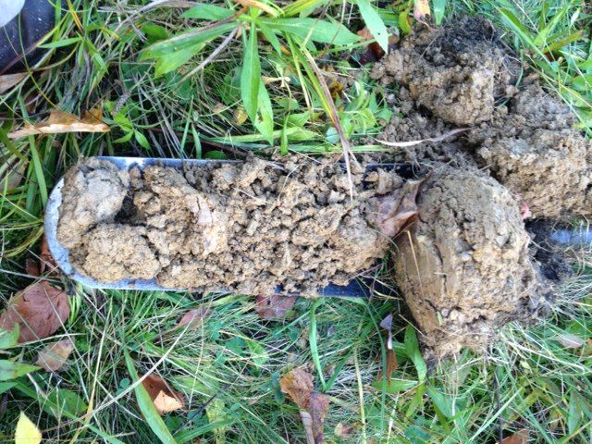
Photo 1 – Soil profile from a test pit at Spencer Woods Detention Pond. Note the organics on top with the soil becoming more gray and mottled towards the bottom.
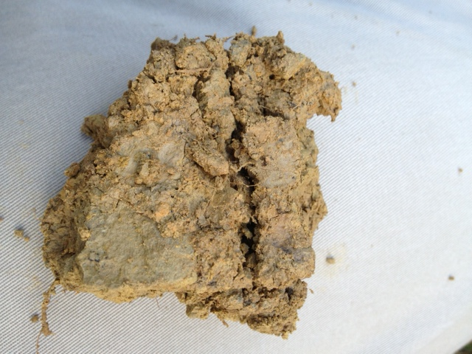
Photo 2 – Close up view of portion of lower soil profile. Note the redoximorphic inclusions (mottles) and the graying of the soil indicating hydric soil potential.

Step 5 – Determine extent of topography and riser structure changes to be made during retrofit
Wetlands work by slowly allowing water to filter through their natural topographies and soils. Wetlands act like nature’s kidneys in this respect, as the filtration helps traps pollutants that in turn get absorbed by the wetland plantings and soils where they are naturally broken down.
In order for that to occur, the flow path of the water through the wetland (or in this case retrofitted detention pond) must be slowed down. Two ways to accomplish this task are through the use of forebays or introducing sinuosity to the main flow channel to the riser structure.
Forebays are small depressions at the head of the pond where the majority of water first enters. In the case of Spencer Woods, the majority of directed water to the pond comes via two storm sewer outlets that empty into it. A forebay could be created to trap this water in a 12-24” depression and force it to build up before it even enters the flow channel to the riser structure. This would help solids settle out, plus other pollutants to drop out as well.
Sinuosity is the amount of curvature within a flow path. In nature, creeks, streams, and rivers do not flow in straight paths. Due to geographical considerations, there is a degree of natural sinuosity to every flowing body of water; it is mankind that has created straight flow paths in these bodies in the name of efficiency. By introducing sinuosity to the main flow channel in the Spencer Woods pond, it will help slow down the travel time to the riser structure and help with filtration. Shown below is a current condition photo of the Spencer Woods pond. The storm sewer entry points are at the top of the picture and form the top of the “Y” of the flow channel to the riser structure at the bottom of the picture.
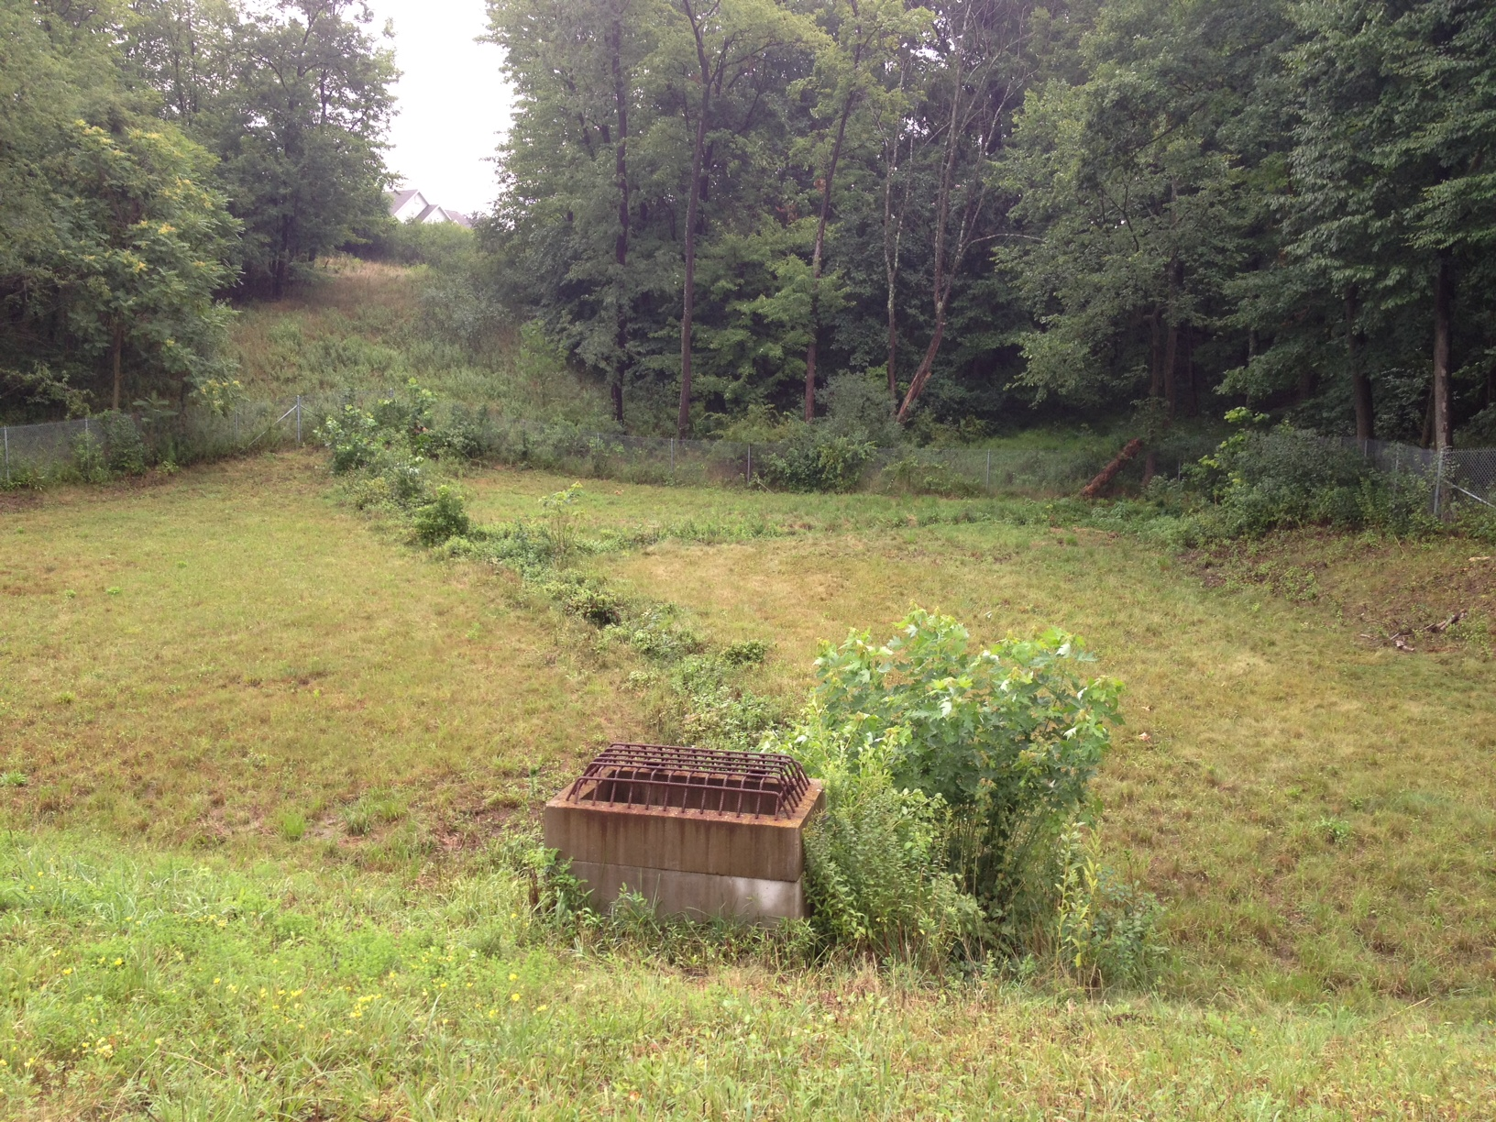
Photo 1 - View of pond looking east from atop berm
Creating microtopography, small undulations to the base of the pond, can be accomplished by having the contractor dig small (6” in depth, typically) depressions and utilizing that excavated soil to create correspondingly-sized mounds. This lends a more naturalistic element to the project. As can be seen above, the current pond is a bland-looking meadow in its current state.
The riser structure at Spencer Woods, as with most detention ponds of the 1980’s and 1990’s era, has a low-flow orifice at the base of the structure. On all but the heaviest of rains, this orifice typically allows all of the flows through with no detention given. As part of any retrofit, this low-flow orifice should be raised up to the calculated 1-year storm level for the detention pond. In lieu of a provided storm water management study or being able to complete a study, raise the bottom orifice up 6” from the base of the pond. This will allow ponding within the retrofitted pond, plus natural saturation and filtration to occur through the soils and wetland plantings.
The current riser structure at Spencer Woods has an orientation as shown below:
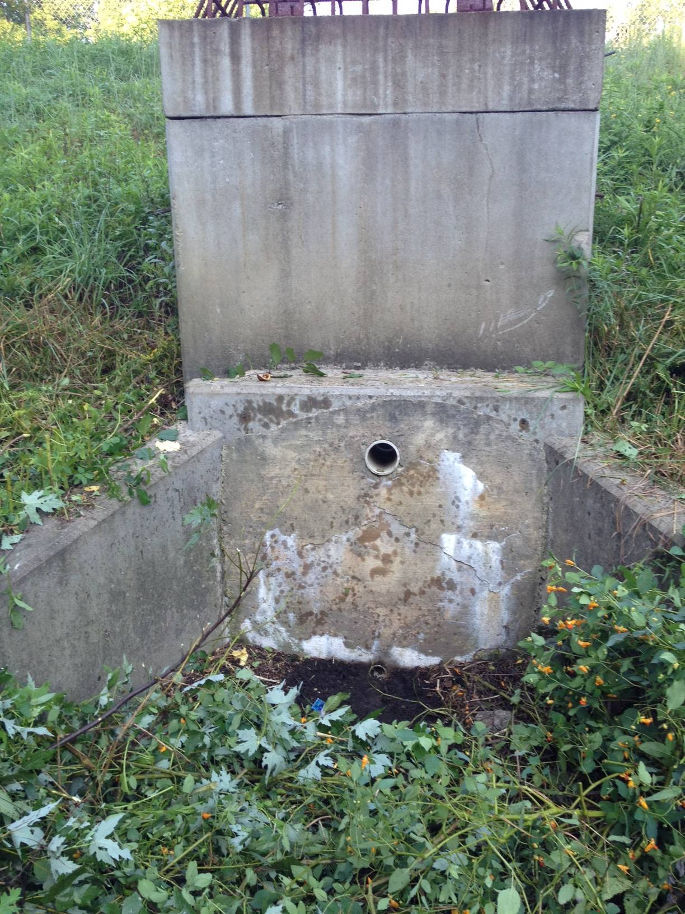
Photo 2 - View of riser structure. Note 2” orifice at very base of structure uncovered from dirt and leaf matter.
The only change suggested would be to raise the 2” orifice up 6” from the base of the structure. As can be seen at the base of the headwall, the 2” orifice has a tendency to get clogged by debris as constructed today, as is.
If at all possible, the municipality can also try and use natural materials (such as on-site felled logs) to create small blockades within parts of the wetland to allow water to be retained for short periods of time before being discharged. This will help extend the time that it takes water to flow from the beginning of the wetland to the riser structure at the end of the wetland.

Step 6 – Select wetland plantings for the retrofitted pond
When retrofitting a detention pond into a storm water wetland, certain types of plants should be considered for their hardiness and ability to tolerate ponding/flooding conditions. It is important to check that these plants are able to tolerate potential ponding of 6 to 9 inches in depth. These types of plants should be of the Obligate (OBL) or Facultative Wet (FACW) classification for wetland plant identification.
The sedge family is a stalwart wetland plant and would be the backbone of any potential retrofit. Sedges such as Button Sedge (Carex bullata, OBL), Pennsylvania Sedge (Carex pennsylvanica, FACW), Black Sedge (Carex nigra, FACW), and Fox Sedge (Carex vulpinoidea, OBL) are just four varieties of sedge that could be possibilities. Sedges are easily identified by their triangular leaves with serrations to the touch when you run your fingers backwards along the leaf – leading to the phrase “sedges have edges”.
Bulrush is another hardy wetland plant for consideration. Hard Stem Bulrush (Scirpus acutus, OBL), Olney’s Bulrush (Scirpus americanus, OBL), Wool Grass (Scirpus cyperinus, FACW), and Three-Square Bulrush (Scirpus pungens, FACW).
The final portion of the triad of recommended wetland plants are Rushes. Canada Rush (Juncus Canadensis, OBL), Soft Rush (Juncus effuses, FACW), Narrow-Panicle Rush (Juncus brevicaudatus, OBL), and Round-Head Rush (Juncus validus, FACW) are four of the potential Rushes for this application.
Other common backbone-style plants are Asters, Joe Pye Weed, with Ferns acting as a good transition between the retrofitted wetland base and the upward sloping sides of the remaining pond.
Although this project is not to be confused with a more decorative rain garden application, the use of sporadic color would help to enhance the site from demonstration purposes. Plants such as Blue Flag (Iris versicolor, OBL), Green-Headed Coneflowers (Rudbeckia lacinata, FACW), and Sweet White Violet (Viola blanda, FACW) are some of the many types of wetland plants that will also provide a splash of color to the potentially retrofitted detention pond.

Step 7 – Establish a pre and post-construction monitoring procedure
It will be important for a municipality to determine the amount of flow potentially removed from a detention pond retrofit. All rainfall events over 0.5”/24 hour period will be considered as data points for the pre and post-construction monitoring.
First, the baseline outflow should be established by installing a weir on the outlet pipe from the basin. At Spencer Woods, this would be placed on the outfall pipe (18” diameter) and monitored for 6 months, preferably during the rainy spring season for a portion of that time.
After the detention pond has been retrofitted, including raising up the lowest orifice and creating infiltration potential, the weir will remain in place and monitored during the same 6 month time period. Rainfall data between these two years will need to be correlated, so as not to jaundice data during an usually wet or dry period.
Additionally, a high water marker should be installed within the detention pond itself to determine the relative depth in the pond after significant events. This marker should be checked within 24 hours of the end of the storm event and measured for depth.

Conclusions
Retrofitting a detention pond may not be in the best interest for every municipality. There will be additional maintenance concerns for these basins, as unintended plant growth or weeds will need to be removed, so as to not impair the functionality of the wetland. Although the aesthetics of the starkly graded, deep detention pond can be improved as a retrofitted wetland through the use of flowering wetland-tolerant plants, some observers may feel that a “weedy swamp” actually lessens the aesthetics. There will also be a concern about mosquitoes and the West Nile virus that they potentially transmit, so a retrofitted wetland should probably not be done at a site directly in a neighborhood backyard.
However, if a pond has been vetted to be a candidate for a retrofitted wetland and has the potential for hydric soils and the hydrology to support wetland vegetation, the project could greatly enhance the water quality and sediment control within a watershed. Benefits can include the minimizing of incising stream channels and eroding streambanks, improving water quality from the first 1 inch of rainfall, and providing increased aesthetics to detention ponds that can be stark and unsightly at times.

