DEVELOPMENT OF A GREEN ROOF STORMWATER MONITORING PROTOCOL AND GREEN ROOF STORMWATER MODELING TOOL

Final Report to

3 Rivers Wet Weather, Inc.

3901 Penn Avenue, Bldg. #3
Pittsburgh, PA 15224

by

David M. Carothers

David A. Dzombak, Ph.D., P.E., DEE

Carnegie Mellon University

Department of Civil and Environmental Engineering

Pittsburgh, PA 15213

December, 2005
Table of Contents
Section Page
Abstract iii
Acknowledgements vii
List of Figures ix
List of Tables xi

1. INTRODUCTION 1
2. BACKGROUND 3
2.1 Stormwater Monitoring at Two Ecoroofs in Portland, Oregon 3
2.2 Vancouver Public Library Green Roof Monitoring Project 5
2.3 Stormwater Detention and Retention Abilities of Green Roofs 8
2.4 Other Green Roof Flow Monitoring Projects 11

3. ROOF TYPES 13
3.1 Flat Roofs 13
3.2 Shallow-Slope Roofs 14
3.3 Steep-Slope Roofs 15

4. MONITORING APPROACHES FOR DIFFERENT ROOF TYPES 16
4.1 Flat Roof Monitoring Methods 17
4.2 Shallow-Slope Roof Monitoring Methods 17
4.3 Steep-Slope Roof Monitoring Methods 18

5. ROOF MONITORING AREA PARTITIONING 19
6. FLAT ROOF MONITORING METHODS 23
6.1 Open Channel Monitoring (Flume) 23

6.1.1 Ultrasonic Sensor 25
6.1.2 Pressure Probe 26
6.1.3 Bubbler Sensor 27
6.1.4 Physical Gauge 28

6.2 Closed Pipe Monitoring 28

6.2.1 Inline Closed Pipe Monitoring 29

6.2.1.1 Nutating Disc 29
6.2.1.2 Magnetic Flowmeter 30
6.2.1.3 Doppler Sensor 32
6.2.2 Collection Methods 34

6.2.2.1 Cistern / Tank Level Sensors 35

6.2.2.1.1 Pressure Probe / Transducer 35
6.2.2.1.2 Magnetic Float Gauge 36
6.2.2.1.3 Physical Gauge 38

6.2.2.2 Bucket and Stopwatch 39
6.2.2.3 Tipping Bucket 39

7. SHALLOW-SLOPE ROOF MONITORING METHODS 40
7.1 Open Channel Monitoring 40
7.2 Closed Pipe Monitoring 42

7.2.1 Inline Monitoring for Shallow-Slope Roofs 43
7.2.2 Collection Monitoring for Shallow-Slope Roofs 44

8. STEEP-SLOPE ROOF MONITORING METHODS 46
9. PRECIPITATION MONITORING 47
9.1 Sensing Technology 47
9.2 Available Precipitation Data Resources 48

10. CASE STUDY: HAMERSCHLAG HALL, CARNEGIE MELLON UNIVERSITY 49
10.1 Green Roof Description 49
10.2 Green Roof Monitoring Areas 51
10.3 Control Roof 55
10.4 Design of Green Roof Water Flow Monitoring System 57
10.5 Green Roof Monitoring Plan 59

11. GREEN ROOF WATER BALANCE MODEL 63
11.1 Water Balance Approach 63
11.2 Empirical Water Balance Model for Green Roofs 64
11.3 Example Applications of Empirical Water Balance Model 65
11.4 Local and General Applications of the Model 71

12. REFERENCES 74

Abstract
As demonstration green roof projects are undertaken in Pennsylvania and elsewhere, it will be important to (a) design them for maximum stormwater retention/diversion benefit, (b) monitor them to determine quantitatively their performance for stormwater retention/diversion and water quality modification, and (c) conduct the monitoring and data reporting in a consistent manner so that the performance of green roofs of different designs and/or in different location can be compared. It is only the demonstrated engineering performance of green roofs, with data acquired by consistent, scientifically sound protocols, that will justify expanded investment by communities and private organizations in widespread implementation of green roof technologies. Further, it is only detailed engineering performance data obtained in a consistent manner that will enable determination of optimal designs for implementation in particular climatic conditions such as Pennsylvania.

In this study, best practices currently in use in Europe and the U.S. were identified, their suitability for implementation in Pennsylvania was assessed, and new methods were developed as needed considering the types of roofs on which green roofs are expected to be implemented in Pennsylvania. Methods and procedures for monitoring stormwater retention and diversion on green roof projects were developed for each of three different roof types: flat, shallow-slope, and steep-slope.

For any type of green roof, it is important to establish the area of the roof that will be monitored. If the entire roof is unable to be monitored then a representative sub-area must be chosen. Factors that should be considered when choosing a representative sub-area are depth of growing medium, types and distribution of plants, slope of roof, exposure to sun and rain, and overall area.

Different stormwater discharge monitoring methods are applicable for different roof types. Two methods that can be implemented for monitoring of flow from green roofs are open channel or flume monitoring and closed pipe monitoring. The flume monitoring method directs the green roof drainage through a flume and then a sensor is used to determine the water depth; and by correlation the flow, within the flume. Sensors appropriate for flume monitoring are the ultrasonic sensor, pressure probe sensor, bubbler sensor, and physical gauge. The closed pipe method uses a sensor mounted within a pipe to determine the flow rate of the green roof drainage. Sensors appropriate for closed pipe monitoring are the nutating disc, magnetic flowmeter, and Doppler sensor. A simple version of the closed pipe monitoring method is the collection method. The collection method involves collecting the water discharged from a green roof at a central location to be monitored. Sensors appropriate for the collection method are the pressure probe/transducer, magnetic float gauge, physical gauge, and tipping bucket rain gauge. There are several possible combinations of methods and sensors that are applicable to each roof type.

In addition to monitoring the stormwater discharge is important to monitor the precipitation falling on the green roof. To do this a tipping bucket rain gauge should be placed on or near the monitored area of the green roof. By monitoring the precipitation the water inflow rate and volume can be determined and compared to the outflow. If a tipping bucket rain gauge is unavailable rainfall data can be obtained on the internet from the national weather service for a nearby location.

An example design of a green roof stormwater monitoring system is provided by the Hamerschlag Hall (HH) green roof at Carnegie Mellon University. A case study is provided that describes the features of the HH green roof, the stormwater monitoring system designed for and installed on the roof, and the monitoring plan. The HH green roof is a 4500 square foot flat roof that was retrofitted on an existing building. Two monitoring areas of 650 square feet each were partitioned and the stormwater outflow is monitored with flumes and ultrasonic sensors. A conventional roof just to the south of the HH green roof was established as a control. The 710 square foot control roof was partitioned and monitored with a flume and ultrasonic sensor just as the HH green roof. A tipping bucket rain gauge was placed between the two roofs to gather precipitation data. The data collected from the sensors is carried through wires encased in PVC conduit to a data logger located in an office below the HH green roof. The data logger is connected to a computer on which LabView software is installed. The LabView software is use to interpret and organize the sensor data.

A green roof water balance model was created to assist with data interpretation and assessment of green roof performance. From the difference of inflow and outflow data a combined evapotranspiration/accumulation rate, or retention rate, can be determined. This retention rate can be related to rainfall and physical properties of the green roof such as, growing medium thickness, roof slope, plant density, and temperature. How these factors affect the performance of a green roof can be determined by relating them to the retention rate of the roof. With collection of empirical data for a green roof over a range of storm events, average values can be developed for the empirical parameters in the water balance model and it can be used to predict retention rates for the roof. As more roofs are monitored, a database of results will allow development of global averages for model parameters and the water balance model could be used in design of green roofs, and prediction of stormwater retention performance regardless of roof type or location.

Acknowledgements

Planning, design, and installation of the Hamerschlag Hall green roof at Carnegie Mellon University served as a useful research case study for development of many of the green roof monitoring approaches described in this report. The authors would like to thank members of the Carnegie Mellon Hamerschlag Hall green roof design team, including Professor Cliff Davidson of Civil and Environmental Engineering, Ms. Megan Snyder of Architecture, Professor Bob Bingham and Ms. Diane Loviglio of Art, and Ms. Barb Kviz, Mr. Brad Hochberg, and Mr. Jim Secosky of Facilities Management Services for their assistance and aid with technical matters associated with green roof sensors and green roof monitoring procedures. Also providing valuable assistance were Tim Clement and his colleagues of W.P. Hickman Systems Inc., the roofing designer and builder, and Jörg Breuning of Green Roof Services, LLC, who was a consultant for the design.

Professor Robert Ries and his student Dan Bliss of Civil and Environmental Engineering at the University of Pittsburgh were generous in sharing knowledge and insights gathered in their work on green roof performance and monitoring.

This project was supported by the Three Rivers Wet Weather (3RWW) Demonstration Program, Pittsburgh, Pennsylvania. Ms. Joan Blaustein of 3RWW served as project officer. Her vision for the potential of green roofs to improve stormwater management in Pennsylvania was the inspiration and guiding force for this project.

List of Figures
Figure 2.1: Flow monitoring station photographs, Hamilton apartment building roof, Portland, OR. Source: Hutchinson et al., 2003 4
Figure 2.2: 5/8” T-10 NSF61 nutating disc meter for monitoring small flows, Vancouver Public Library green roof. Source: Johnston et al., 2003 6
Figure 2.3: 2” T-10 nutating disc meter for monitoring large flows from Vancouver Public Library green roof. Source: Johnston et al., 2003 7
Figure 2.4: Metered piping system schematic for Vancouver Public Library green roof. Source: Johnston et al., 2003 7
Figure 2.5: Meter piping system, level P1 Vancouver Public Library Parking Garage Source: Johnston et al., 2003 8
Figure 2.6: Plan View of Building Layout and Schematic Cross-Section. Source: Denardo et al., 2003 9
Figure 2.7: Runoff collection and measurement system for a test building at the Pennsylvania State University green roof field test facility. Source: Denardo et al., 2003 10
Figure 3.1: Roof Slope Classifications 13
Figure 3.2: Example of Flat Green Roof. Source: Hutchinson et al., 2003 14
Figure 3.3: Example of Shallow Slope Green Roof. Source: http://www.greenroofs.com/north_american.htm 15
Figure 3.4: Example of Steep-Slope Green Roof. Source: http://www.treehugger.com/files/architecture/index.php 15
Figure 6.1: Trapezoidal Flumes. Source: http://www.plasti-fab.com/flumes/trapezoidal/trapezoidal.html 24
Figure 6.2: Example of flume/weir monitoring method 25
Figure 6.3: Ultrasonic sensor. Source: http://www.fondriest.com/products/stevens_str.htm 26
Figure 6.4: Pressure Probe. Source: http://www.nexsens.com/product/catalog/pressure_level_sensor.htm 27
Figure 6.5: Bubbler Sensor. Source: http://www.nexsens.com/product/catalog/o_bubble.htm 28
Figure 6.6: Inner workings of a nutating disc flowmeter. Source: http://www.aaliant.com/pdfs/M110.pdf 30
Figure 6.7: Wafer style magnetic flowmeter. Source: http://www.omega.com/prodinfo/magmeter.html 31
Figure 6.8: Insertion style magnetic flowmeter. Source: http://www.omega.com/prodinfo/magmeter.html 31
Figure 6.9: Example of a Doppler Sensor for measurement of flow velocity. Source: http://www.omega.com/toc_asp/frameset.html?book=Green&file=ultrasonic_flow_ref 33
Figure 6.10: Examples of pressure transducers. Source: http://www.omega.com/prodinfo/pressuretransducers.html 36
Figure 6.11: Illustration of magnetic float gauge. 37
Figure 6.12: Examples of magnetic float gauges. Source: http://www.iprocessmart.com/Babbitt/liquid_level_gage.htm 38
Figure 7.1: Cross section of flume on roof monitoring system for a shallow-slope roof 40
Figure 7.2: Plan view of flume on roof monitoring system for a shallow-slope roof 41
Figure 7.3: Plan view of flume in gutter monitoring system for a shallow-slope roof 41
Figure 7.4: Downspout to flume monitoring system for shallow-slope roofs 42
Figure 7.5: Inline downspout monitoring system for shallow-slope roofs 44
Figure 7.6: Collection monitoring system for shallow-sloped roofs 45
Figure 9.1: Tipping bucket rain gauge. Source: http://www.globalw.com/products/rg600.html 48
Figure 10.1: Green roof location on Hamerschlag Hall, Carnegie Mellon University 49
Figure 10.2: Plan view layout of Hamerschlag Hall green roof and control roof 50
Figure 10.3: Picture of Hamerschlag Hall green roof 50
Figure 10.4: Hamerschlag Hall green roof cross section 51
Figure 10.5: Dimensions of a Hamerschlag Hall green roof water monitoring area 52
Figure 10.6: Curbing for monitoring areas on the Hamerschlag Hall south roof 53
Figure 10.7: Piped downspout from upper roof onto the Hamerschlag Hall south roof 53
Figure 10.8: Downspout pipe locations on the Hamerschlag Hall south roof 54
Figure 10.9: Hamerschlag Hall green roof monitoring area cross section 55
Figure 10.10: Control roof curbing 56
Figure 10.11: Control roof flume 56
Figure 10.12: Plasti-Fab flume and Stevens Ultrasonic water level sensor 57
Figure 10.13: Rain gauge stand on Hamerschlag Hall green roof 58
Figure 10.14: Hamerschlag Hall green roof sensor wire collection box. 59
Figure 10.15: Interior of Hamerschlag Hall green roof sensor wire collection box 60
Figure 10.16: Completed wire collection box on Hamerschlag Hall green roof. 60
Figure 10.17: National Instruments FieldPoint data logger. Source: http://sine.ni.com/nips/cds/view/p/lang/en/nid/2178 61
Figure 11.1: Green roof mass balance diagram 64
Figure 11.2: Hypothetical inflow and outflow data for water balance model example application 66
Figure 11.3: Net retention data with inflow and outflow data for water balance model example application 68
Figure 11.4: Empirical retention coefficient results for the water balance model example application 71
Figure 11.5: Empirical retention coefficient results for the simplified water balance model example application 73

List of Tables
Table 11.1: Hypothetical Inflow and outflow data for water balance model example application 66
Table 11.2: Green roof water retention data for water balance model example application 68
Table 11.3: Integrated volumes for inflow, outflow, and retention for example application 69
Table 11.4: Empirical retention coefficient data for the water balance model example application 70
Table 11.5: Empirical retention coefficient data for the simplified water balance model example application 72

1. INTRODUCTION
Green roofs have been used in Europe for years and are well established, but they are just beginning to gain popularity in the United States (Hutchinson et al., 2003). Green roofs are of increasing interest in urban areas as a means of mitigating the urban heat island effect, of improving energy efficiency in buildings, and of reducing stormwater runoff problems (Herman, 2003). The rate and volume of runoff in urban areas can be reduced with green roofs through reduction in the amount of conventional roof impervious surface area in watersheds. Municipalities, particularly those with combined sanitary and storm water systems, are facing increased pressure to eliminate overflow events (Slone et al., 2003). Green roofs have potential to help mitigate wet weather sewer overloads in Pennsylvania. Green roofs absorb and evaporate back into the air a considerable part of rain water, thereby reducing and/or delaying the runoff load on the sewage system (Lindhqvist, 2003). Expanded use of green roofs in the Pittsburgh region promises to reduce the volume and flow rate of stormwater runoff that contributes to sewer overloads.

There are two categories of green roofs, intensive and extensive (Miller, 2005). Intensive green roofs are traditional-style roof gardens, with large trees and shrubs. They often are accessible to the public and can include garden paths, seating, and other features. Intensive green roof are more commonly found on flat roofs and are meant to be similar to a park. As suggested by the name, they are labor-intensive, requiring irrigation and maintenance. Intensive roofs are multi-layer constructions, with approximately eight inches to four feet of soil depth (Worden et al., 2004).

Extensive roofs are used more for environmental benefits and are not designed for public use. They are intended for low maintenance and to mitigate the effects of urbanization on water quality, stormwater runoff, and solar heat absorption. Extensive green roofs can have a soil depth of approximately one to seven inches (Worden et al., 2004). They are constructed of a layer of lightweight soil medium placed above a drainage layer and an impermeable membrane. The drainage layer is necessary on roofs with shallow slopes to drain excess water away from the root layer. Extensive green roofs can be installed over various roof decks with a range of slopes.

Performance monitoring of green roof installations in Europe and in North America has been mostly qualitative. Detailed engineering performance data are just starting to be acquired, using a variety of measurement techniques and tools. No consistent approaches have yet evolved.

This report provides a summary of available methods for monitoring stormwater runoff flow rate and volume from green roofs, and provides recommended monitoring methods for different types of roofs. A simple water balance model for describing and predicting the performance of green roofs is also presented. The report is intended to be used as a source of information about different methods, procedures, and sensors available to monitor stormwater runoff from conventional and green roofs. It can also be used as a guide to determine appropriate methods, procedures, and sensors for monitoring roof runoff for different applications and roof types.

2. BACKGROUND
With the increasing interest and popularity of green roof projects for stormwater retention and flow reduction properties there is also developing interest in monitoring the performance of green roofs of different types, designs, and locations. Most of the reports relating to the performance of green roof installations have been qualitative. A range of detailed and quantitative data measurements have started to be obtained using several different measurement tools and techniques. Standard methods for monitoring the performance of green roofs have not yet been developed, but there have been field tests and demonstrations of several kinds of monitoring techniques. Some of these applications and tests are described here.

2.1 Stormwater Monitoring at Two Ecoroofs in Portland, Oregon
In Portland, Oregon, the City of Portland Bureau of Environmental Services is investigating the stormwater management capabilities of green roofs for wide spread applications (Hutchinson et al., 2003). Portland has performed stormwater runoff monitoring on residential and large building “ecoroof” projects. A large-roof building where stormwater runoff was monitored is the Hamilton Apartment Building. The Hamilton roof was divided into two areas for research purposes. The first area was 2,520 square feet and was covered with three inches of growing media. The second area was 2,620 square feet and was covered with five inches of growing media. Rainwater falling on roof areas outside the vegetated area was diverted directly into a roof drain. All rainwater falling onto the vegetated areas of each section of the roof was channeled through a small 60 degree V-trapezoidal Plasti-Fab flume (Figure 2.1). Inside the flume an American Sigma Model 950 bubbler sensor was used to determine the water level within the flume so the flow rate and also the volume of runoff could be determined. The method of using the flume and the bubbler sensor are discussed in detail later in the report.
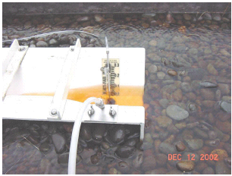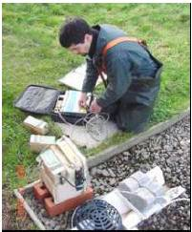
Figure 2.1: Flow monitoring station photographs, Hamilton apartment building roof, Portland, OR. The left shows a close-up of the flume during a storm event and the right shows the flume and flow monitor. Source: Hutchinson et al., 2003

The monitoring equipment was set up and started recording data in December 2001 and continued until April 2003. After reviewing the monitoring data from the east roof it was determined that the stormwater runoff values were greater than the stormwater falling on the roof. It was believed that the gutter system for a portion of a conventional roof was malfunctioning during heavy rainfall events and allowing water to flow onto the green roof. Due to this difficulty only the data from the west roof were examined.

Results from the west roof monitoring in Hutchinson et al. (2003) were obtained over a 15 month period. When examining the difference between rain run-on and runoff for the west roof it was determined that the green roof retained 69% of incipient precipitation, and that retention appeared to increase with time. It was determined that the retention rates varied greatly from the months of January, February, and March of 2002 and 2003. The retention rate for January to March 2002 was 20% compared to the same months in 2003 the retention rate was 59%. Although both periods had similar rainfall amounts they differed in rainfall patterns and distribution. There were long dry periods between storms in 2003 compared to more continuous rainfall in 2002. It was hypothesized that the long dry periods allowed the green roof to use and retain more water than during the periods of more continuous rainfall of 2002. Another factor leading to the differences in green roof water retention between 2002 and 2003 was a difference in the average daily temperature. During January through March of 2002 the average daily temperature was 2.4 degrees Fahrenheit lower than that of 2003 for the same period. It is believed that the higher temperature could contribute to a greater evaporation and evapotranspiration rate allowing the roof in 2003 to retain and evaporate more water then it could in 2002. A third factor that was believed to contribute to the difference in retention rate between 2002 and 2003 was the plant maturity. This was likely the most significant factor. As green roof plants grow, develop more ground cover, and establish a greater root system they are able to use and retain more water, therefore leading to an increasing trend in the stormwater retention. It was also determined that the green roof was able to retain 100% of most low intensity warm weather storms.

2.2 Vancouver Public Library Green Roof Monitoring Project
The Vancouver, British Columbia Public Library has a green roof with a system that is used to monitor stormwater runoff (Johnston et al., 2003). The roof consists of an extensive green roof with a net area of 1,500 square feet. Two drains are used for the green portion of the roof and these drains are piped to a lower level of a parking garage where stormwater passes through flow meters and is then discharged into the city’s stormwater system. There are two different flow meters in the system, one used for low flows and one for high flows. The low flow meter is a 5/8” T-10 NSF61 Meter calibrated to 1 liter per pulse (Figure 2.2). The large flow meter is a 2” T-10 Meter that is comprised of three parts: a register, a maincase, and a nutating disc (Figure 2.3). The maincase is used to resist internal pressure stresses and external damage to protect the nutating chamber located inside. The nutating disc rotates in a circular motion as water flows through it and is then discharged. The TRICON®/S Register mounts to the maincase and records the pulses from the nutating disc and sends the results to a data logger. The large flow meter is calibrated to 10 liters per pulse. If the meters malfunction there is a pressure relief valve and a bypass valve that will allow the stormwater to be diverted from the flow meters and discharged directly into the stormwater system.

A schematic of the Vancouver Public Library water system and a photograph of the setup can be seen in Figures 2.4 and 2.5, respectively. Some regular maintenance is required with this system such as cleaning debris from the strainers. It is very important that no debris be allowed to enter the nutating disc, and also that flow is not restricted within the pipe. To prevent these problems, the strainer for the large flow meter is cleaned every three months and the low flow meter is cleaned every two weeks.

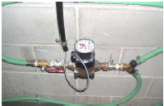
Figure 2.2: 5/8” T-10 NSF61 nutating disc meter for monitoring small flows, Vancouver Public Library green roof. Source: Johnston et al., 2003

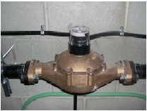

Figure 2.3: 2” T-10 nutating disc meter for monitoring large flows from Vancouver Public Library green roof. Source: Johnston et al., 2003

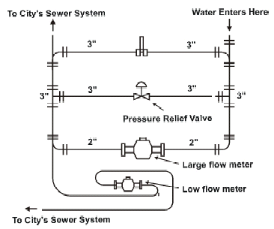

Figure 2.4: Metered piping system schematic for Vancouver Public Library green roof. Source: Johnston et al., 2003

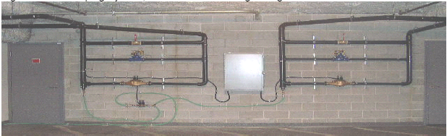
Figure 2.5: Meter piping system, level P1 Vancouver Public Library Parking Garage Source: Johnston et al., 2003

Johnston et al. (2003) reported flow monitoring results from the Vancouver Public Library green roof for July 2003 to February 2004. The data gathered from this green roof show a 48% reduction in stormwater runoff when compared with that estimated for the pre-development conventional roof on the Vancouver Public Library. Since only 80% of the roof is covered by the green roof, it was estimated that if the entire roof was covered by the green roof the stormwater runoff reduction would be close to 70%. It was also observed that the green roof could detain the water and slow the occurrence of the peak runoff outflow. The green roof was able to attenuate the summer peak flows to greater than 80% and smaller winter peak outflows by approximately 30%. It was determined that during intense storm events the green roof was unable to attenuate the peak outflow.

2.3 Stormwater Detention and Retention Abilities of Green Roofs
At the Russell E. Larson Agricultural Research Center at Rock Springs, Pennsylvania the Pennsylvania State University departments of Agricultural and Biological Engineering and Horticulture combined efforts to conduct a research experiment on the stormwater retention abilities of a green roof system (DeNardo et al., 2003). The research experiment used six different 48 sq. ft. test buildings consisting of three with conventional roofs and three with green roofs. The three control roofs were constructed with a conventional asphalt membrane and the three green roofs were constructed over the conventional roof’s waterproof membrane. The layout of the buildings and experiment can be seen in Figure 2.6.

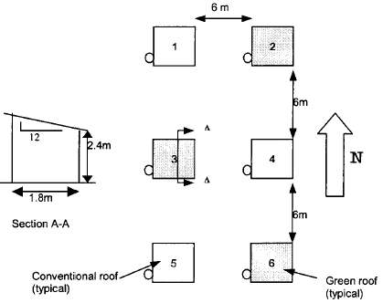
Figure 2.6: Plan View of Building Layout and Schematic Cross-Section. Buildings two, three, and six have green roofs. Buildings five, four, and one have conventional roofs. Source: Denardo et al., 2003

Each test building had its own stormwater drainage system via a roof gutter and downspout. The downspouts were routed into a collection barrel equipped with a pressure transducer to monitor water depth. Through the use of the pressure transducer the change in the hydrostatic pressure at the bottom of the barrel over a given time interval and the known cross sectional area of the barrel allows one to determine the flow rate of storm water. The pressure transducers send a signal to a central data logger and then to a personal computer at 30 second intervals during storm events. A schematic of the experimental setup on one test building can be seen in Figure 2.7.

Rainfall amounts during storm events were recorded at one hour intervals by a weather station located on Building 1. By comparing the rainfall amount recorded by the weather station to the observed runoff for the conventional roofs and green roofs the stormwater flow reduction performance of the green roof was assessed.

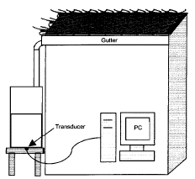
Figure 2.7: Runoff collection and measurement system for a test building at the Pennsylvania State University green roof field test facility. Source: Denardo et al., 2003

Monitoring results for the Penn State green roof test facility from July to November 2002 are presented in Denardo et al. (2003). The results focus particularly on two storm events in October 2002 and also average results over the five month sample period. The first storm event discussed occurred on October 25-26, 2002, six days after a previous storm. The October 25-26, 2002 event had a cumulative rainfall of 24 mm (0.94 in) and the cumulative runoff from the green roofs averaged 19.4 mm (0.76 in). This corresponds to 20% of the rainfall being retained. Up until five hours after the storm event began the green roofs produced no measurable runoff. During this first five hours of the storm event 11 mm of precipitation fell. Of this 11 mm, 6.4 mm of precipitation was detained on the green roofs for temporary storage. The second storm event discussed by Denardo et al. (2003) occurred on October 16, 2002 three days after a preceding storm. This event had a cumulative rainfall of 21.5 mm (1.13 in) with the green roofs retaining 6.5 mm or 23% of the precipitation. The detention time for the runoff was three hours, therefore differing from the October 25-26 storm event by two hours. During this initial three hour period only 3.0 mm of precipitation fell. Throughout the five month monitoring period several small storms (< 4 mm) occurred for which the green roofs retained essentially 100% of the precipitation. For one storm event in August the green roof was observed to have less than 20% retention, while for another in November close to 33% retention was observed. Examination of the data collected for all storms revealed that green roofs typically retained between 20% and 30% of incipient precipitation. It was also observed that the runoff amount from the conventional roofs was less than that of the storms. It was hypothesized that this was due to rain splashing off the roof and also the effect of the wind on the precipitation. A conclusion from this study was that there was no correlation between the precipitation retained and the time between storm events.

2.4 Other Green Roof Flow Monitoring Projects
Correspondence with the German green roof designer Jörg Breuning revealed that the main method of monitoring green roofs in Germany is similar to that employed at the test facility of Pennsylvania State University (Breuning 2005). Through this method the runoff from a green roof is collected in tanks, and the water level in the tank is monitored with time. Change in the water level over a given time interval gives the runoff flow rate from the green roof. This method is very labor and time intensive due to the need to have a person drain the runoff holding tanks when they become full.

Although a holding tank is an entirely viable option for green roof water monitoring and has been proven to be effective, at least for average intensity storms, other flow monitoring options exist such as using an open channel flume or a closed pipe system with a nutating disc. This report describes various approaches and technologies available to monitor green roofs for stormwater runoff in addition to the holding tank method.

3. ROOF TYPES
When considering methods for green roof water monitoring it is important to consider the different types and configurations of roofs. For the purposes of this report it was decided to separate roofs into three different types: flat roofs, shallow-slope roofs, and steep-slope roofs. The classifications are illustrated in Figure 3.1.

1”
4”
12”
Flat Roof
Shallow Slope Roof
Steep Slope Roof
Figure 3.1: Roof Slope Classifications

3.1 Flat Roofs
The first and usually the most common type of roof for the installation of a green roof is a flat roof. An example of a green roof on a flat roof is illustrated in Figure 3.2. Flat roofs usually have a minimal slope created by insulation under the waterproofing membrane to promoted water drainage towards the roof drains. For the purpose of this report a flat roof is one whose slope is between essentially no slope and one unit of vertical rise per twelve units of horizontal run (1:12). These roofs are usually surrounded with parapet walls; located inside these walls are roof drains which carry the water through pipes to the storm sewer or equivalent wastewater system. All the monitoring systems recommended later in the report for flat roofs have taken the characteristics of a flat roof into consideration.

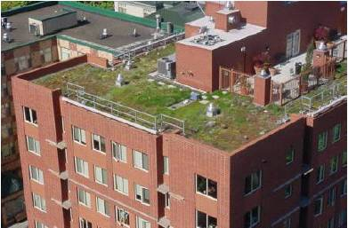
Figure 3.2: Example of Flat Green Roof. Source: Hutchinson et al., 2003

3.2 Shallow-Slope Roofs
The second type of roof is the shallow-slope roof (Figure 3.3). This type of roof is less common for green roof installation, but it has been done and is entirely feasible. A shallow-slope roof is defined as one whose slope ranges from one unit of vertical rise to twelve units of horizontal run (>1:12) and four units of vertical rise to twelve units of horizontal run (4:12). These types of roofs often utilize a gutter and downspout system to convey runoff from the roof to the storm sewer or equivalent wastewater system. All the monitoring systems recommended for shallow-slope roofs have taken the characteristics of a shallow sloped roof into consideration.

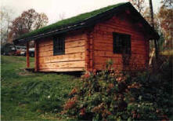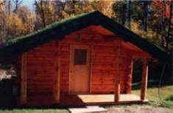
Figure 3.3: Example of Shallow Slope Green Roof. Source: http://www.greenroofs.com/north_american.htm

3.3 Steep-Slope Roofs
The third roof type is the steep-slope roof (Figure 3.4). Steep-slope roofs are defined as roofs having a slope greater than four units of vertical rise to twelve units of horizontal run (>4:12). It is rare to find green roofs on roofs with such a steep slope due to the high potential for erosion of the growing medium. Green roofs have been developed on steep slopes, however, with use of vertical ribbing and other methods to retain growing media. Although green roofs on steeply sloped roofs are rare, advances in green roof technology may lead to more applications on steep slope roofs.
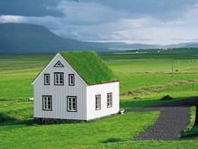
Figure 3.4: Example of Steep-Slope Green Roof. Source: http://www.treehugger.com/files/architecture/index.php
4. MONITORING APPROACHES FOR DIFFERENT ROOF TYPES
Appropriate monitoring methods for stormwater runoff from green roofs depend on the type of roof as classified by slope. In this section some runoff monitoring methods that will work well in conjunction with the three classes of roof types are recommended. The recommended methods can be modified to accommodate various situations and applications. Runoff monitoring methods may be classified as related to two main methods: open channel and closed pipe. Within these methods there are many different sensors and applications that depend on many different factors.

The open channel method appropriate for green roof runoff monitoring involves the use of a small flow flume. When using a flume there are several different sensors that can be used to determine the water level within the flume, including an ultrasonic sensor, pressure probe, bubbler sensor, and a physical gauge. This method may be desirable to be used when a green roof is to be installed on an existing roof and the drainage system is inaccessible. More detailed information on the application of this method for different roof types and available sensors is provided in later sections in the report.

The second general approach for green roof runoff monitoring is the closed pipe method. This method will work best when access to the roof’s drainage system is available or the roof is being constructed with the intention to have a green roof installed on it. There are two different approaches one can take when using closed pipe monitoring. The first uses a cistern or tank to collect storm water and then the water level in the tank can be monitored. Sensors used for this application include a float and a pressure transducer. The second application is using a sensor inline with the drainage system. These sensors include sensors such as a magnetic flowmeter, Doppler sensor, and a nutating disc. More detailed information on the application of this method for different roof types and available sensors is provided later in this report.

4.1 Flat Roof Monitoring Methods
Flat roofs provide the most options for green roof for stormwater runoff monitoring. It is convenient to have a relatively flat surface in which to mount monitoring equipment. A flat roof also makes it possible to install an open channel or flume monitoring systems directly on the roof, as these devices must be installed on horizontal surfaces. The stormwater runoff can also be monitored using the closed pipe method for a flat roof drainage system. For the closed pipe system, a decision is needed about whether to monitor the runoff inline, or use a collection tank.

4.2 Shallow-Slope Roof Monitoring Methods
Shallow-slope roofs are slightly more restrictive than flat roofs when monitoring a green roof for stormwater runoff. It is more difficult to install monitoring equipment on the sloped surface of the roof. It is still possible to use the open channel method and flume to monitor runoff, but the flume must be leveled and connected smoothly and watertight to the roof. Otherwise, the flume could be mounted remotely (e.g. on a horizontal surface at the bottom of a downspout) and the runoff collected and piped to the flume. Another option use of the open channel method would be to create or install a flume within the gutter and monitor the water before it enters the down spout. A flume installed in a gutter system must be level and calibrated to ensure accurate results. The gutter would have to be wide enough to accommodate the flume. The same closed pipe methods that were applicable for a flat roof are also applicable for a shallow-slope roof.

4.3 Steep-Slope Roof Monitoring Methods
It is very difficult to install any kind of stormwater runoff monitoring equipment on a steeply sloped roof. Mounting a flume on the roof would be difficult because of the extreme pitch of the roof and the need to level the flume. It is advisable that if a flume is to be used then it should be mounted within the gutter, or mounted remotely and the runoff piped to it. The closed pipe methods are more applicable for a steeply sloped roof than the open channel method. The stormwater runoff could be monitored in the down spouts through the use of inline flow sensors if the downspouts are flowing full, or the downspouts can be attached to a cistern where the runoff can be monitored.

5. ROOF MONITORING AREA PARTITIONING
When choosing a method for monitoring stormwater runoff from a green roof it is also important to consider the area to be monitored. It is best if the entire green roof can be monitored, but this will often not be feasible due to various factors. Large roofs have several drainage points and it may be infeasible and uneconomical to place monitoring equipment at each of these locations. There may be several different pipes for each of these drainage points which may be difficult to join together in order to use one sensor. A common limitation is that monitoring of the entire green roof area would require very large pipes or storage tanks to accommodate the water flow. Also, a green roof may receive stormwater runoff from roofs above it, and it is undesirable for this runoff to be monitored if the stormwater retention capacity of the green roof is to be assessed. In any of these situations and many more, partitioning the roof to isolate a subsection for stormwater monitoring is a consideration.

When only a portion of the roof will be monitored it is necessary for accurate results that the area being monitored is representative of the entire roof. Further, the monitoring area must be hydraulically isolated from the rest of the roof area. Factors that need to be considered in choosing a sub-area for monitoring include: depth of growing medium, types and distribution of plants, slope of roof, exposure to sun and rain, and overall green roof area

When choosing a representative sample of a green roof for stormwater runoff monitoring it is important to select an area that will reflect the performance of the entire green roof. The first factor to take into consideration is the depth of growing medium. If the depth of the growing medium is uniform over the entire roof then this will not be a limiting factor in choosing a monitoring area. If the depth of the growing medium varies over the green roof then a range of depths or average depth should be included within the monitoring area. If possible the monitoring area would have the same percentage by area of growing medium depths as the entire roof. If there are discrete areas of the roof with different depths of the growing media then multiple monitoring areas may need to be considered.

The second factor to consider when choosing a sampling area is the types and distribution of plants on the green roof. If the plants are all the same species and spaced evenly over the roof then this may not be a limiting factor in selecting a monitoring area. If there are varying plant types and spacing over the roof then this should be represented within the sampling area.

The third factor to consider the selecting a sampling are is the slope of the roof. If the slope is uniform over the entire roof then this may not be a limiting in choosing a monitoring area. If the roof slope varies it would be desirable to include both slopes in the monitoring area, or have separate monitoring areas for different slopes.

The fourth factor to consider is the green roof’s exposure to the sun and rain. If there are no structures or trees surrounding the green roof to block the sun or rain from the roof then this may not a limiting factor in choosing a monitoring area. Since green roofs are most commonly used in urban areas there are often surrounding buildings that can block the sun and rain from the roof. This can affect the results when using a selected area for monitoring stormwater runoff from green roofs. Areas of the roof that receive more sunlight will be more susceptible for water evaporation. Also areas which are blocked from rainfall will not receive as much incipient rainfall as other areas and in inaccurate data may result. Rainfall variations should also be considered when choosing a location for the rain gauge on the green roof. Because of sunlight and rainfall variations the types and distribution of plants my change over time. This is another reason why it is important to observe the amount of sunlight and rainfall that different areas of the roof receive and select a monitoring area that is representative of the roof as a whole.

The final and possibly most important factor when selecting a sample area of a green roof for stormwater monitoring is the overall area that is to be monitored. It is desirable to monitor the entire roof, but if this is not feasible then the monitoring area should be as large as possible. The area of monitoring area will be determined by the layout of the roof and the type of monitoring system to be used. The existing slope of the roof and location of roof drains can affect the size and shape of the monitoring area if an open channel monitoring system is to be used. Also if the roof is receiving drainage from surrounding roofs this can restrict the area and location of a sampling area. An area that can be hydraulically isolated from the adjacent or overlying roof run-on should be selected. The size and duration of a storm event which is intended to be captured should be taken into account when choosing the monitoring area and sensing equipment. If the area is too small the sensing equipment may not be able to read the small amounts of runoff and low flows. If the monitoring area is too large the sensing equipment may become inundated regularly hampering data acquisition. It is recommended that the monitoring system be designed to capture a two year storm of 60 minute duration. This design storm was chosen because it has a very high likelihood of occurring therefore allowing more data to be collected. If a larger design storm is chosen the monitoring equipment will be oversized and therefore unable to capture the smaller more frequent storm events. In order to collect a large amount of data it is desirable to capture data on the small frequent storm events. If the monitoring equipment becomes inundated during large storm events then this is a reasonable sacrifice in order to have the sensitivity to capture many smaller storm events.

6. FLAT ROOF MONITORING METHODS
When monitoring a flat roof for stormwater runoff one can either monitor the water on the roof before it enters the roof drains, or after it has entered the drainage system. There are two main categories of monitoring methods, open channel and closed pipe. To monitor the water before it enters the drainage system, the stormwater should be directed through an open-channel flume to monitor the flow rate and volume of runoff. For monitoring after water has entered the drainage system, the alternatives are either to monitor the runoff as it passes through the pipes, or to collect it in a tank. For any of these options there are a variety of sensors that can be used, with different advantages and disadvantages for each.

6.1 Open Channel Monitoring (Flume)
A runoff flow monitoring method especially well suited for flat roofs is an open channel method that utilizes a flume. Flumes are based on a principle that relates a depth of water to a water flow rate in a channel of known cross-section. The equation relating flow and water depth for a flume is typically in the form:
Q = aH ^{b} (6.1)
Where Q is the volumetric flow rate (e.g., in gallons per minute) and H is the height of water in the flume. Some flumes of trapezoidal cross section are illustrated in Figure 6.1.
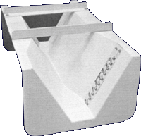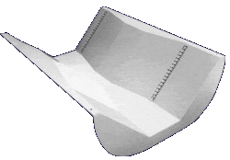
Figure 6.1: Trapezoidal Flumes. Source: http://www.plasti-fab.com/flumes/trapezoidal/trapezoidal.html

By placing flumes in front of each roof drain and forcing rainwater through them, one can determine the flow rate and by integration over time volume of runoff. Weir which are used to measure flows in streams and open channels, are works based on the same principle as a flume, and conceivably could be utilized for flow monitoring on a green roof. However, for monitoring green roofs a flume is more appropriate than a weir as the latter requires a pool of standing water. A flume promotes water flow and drainage and is more appropriate for green roofs.

One can also partition the roof so only the runoff from a designated area will flow through the flume thus reducing the number of flumes if the number of roof drains is large. When a flume is placed adjacent to a drain to collect runoff flow from a particular area of the roof, curbing and flashing will usually be needed to ensure that only flow from the designated area enters the flume. An example of curbing for hydraulic control is illustrated in Figure 6.2.

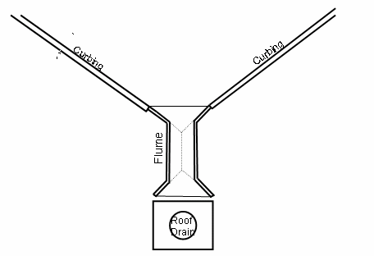
Figure 6.2: Example of flume/weir monitoring method

Using a flume to monitor water runoff from a green roof has its advantages and disadvantages. One major advantage is that it can be installed on the surface of a roof, which allows it to be used in retrofit applications since it doesn’t involve any modifications to the drainage system. This also allows for easy accessibility for maintenance and inspection. A disadvantage of this system is that the water from the roof must be funneled through the flume, making hydraulic control a necessity so that no water from the study area bypasses the flume.

6.1.1 Ultrasonic Sensor
There are a number of approaches and sensors that can be used to monitor the water level in a flume. The first of these sensors is an ultrasonic water level sensor. This sensor would be mounted above the flume. By sending out ultrasonic sound this sensor can determine the water level by recording how long it takes for sound waves to bounce off of the water surface and return to the sensor. The measured water level can then be converted into a flow rate with the use of the appropriate equation for the particular flume. Ultrasonic sensors are usually very precise and have good resolution. They also are mounted above the water so they do not impede water flow and can be used in low flow applications. Ultrasonic sensors are usually not very expensive ($600-$800) when compared to other water level sensors. Some disadvantages are that the sensor should be mounted level and perpendicular to the surface of the water. An example of an ultrasonic sensor is illustrated in Figure 6.3.

Figure 6.3: Ultrasonic sensor. Source: http://www.fondriest.com/products/stevens_str.htm

6.1.2 Pressure Probe
Another sensor that can be used for water level measurement in a flume system is a pressure probe. This sensor uses an internal diaphragm to sense pressure which is governed by a depth of water. The pressure probe would be mounted above the flume or weir with the end at the bottom of the flume. The advantages of a pressure probe are that they are very durable and easy to use. The disadvantages are that they must be placed in the flume, therefore impeding flow. They are also not usually good for low flows and need a minimum depth (e.g. one inch) of water before they can make a reading. Pressure probes are more commonly used for water depths of larger bodies of water such as rivers, lakes, and wells. An approximate cost of a pressure probe is $900. An example of a pressure probe is illustrated in Figure 6.4.

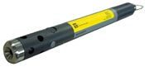
Figure 6.4: Pressure Probe. Source: http://www.nexsens.com/product/catalog/pressure_level_sensor.htm

6.1.3 Bubbler Sensor
Another sensor that can be used to determine the water level in a flume is a called a bubbler. This type of sensor is well suited to use with a flume. The bubbler works by discharging a bubble of air at the bottom of the flume. By sensing how much pressure is necessary to push out the bubble it can determine the depth of water in the flume. There are many advantages for the bubbler including good precision, resolution, and ability to sense the low flows typical of with green roof runoff. The disadvantage with the bubbler is its cost which is around $2000. An example of the bubbler sensor is illustrated in Figure 6.5.

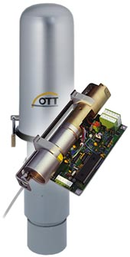
Figure 6.5: Bubbler Sensor. Source: http://www.nexsens.com/product/catalog/o_bubble.htm

6.1.4 Physical Gauge
A sensor that is applicable for use with a flume and by far the most simple and inexpensive, is a physical gauge, usually located on the side of a flume. This can be something as simple as a ruler to measure the water level. The advantages and disadvantages of the physical gauge both lie in its simplicity. A physical gauge is very inexpensive and has no moving parts that can malfunction, and it requires no power and is extremely durable. The shortcomings of the physical gauge are its limited and labor intensive sensing ability. Since the physical gauge isn’t electronic it cannot record data to a data logger at specified timed intervals. It can only be read when a person actually looks at the gauge and records the level manually, a significant limitation for recording flow during rain storm events. The readings can also be inaccurate due to human error and also a limited number of readings.

6.2 Closed Pipe Monitoring
There are two categories of closed pipe monitoring methods: inline and collection. The inline method uses sensors that are installed inline with the roof drainage system and can monitor stormwater flow rates and quantities as the water flows through or past them. The collection method of closed pipe monitoring involves collecting the stormwater runoff in a device of known cross section or volume and monitoring how quickly water is collected.

6.2.1 Inline Closed Pipe Monitoring
Inline closed pipe monitoring uses a sensor that is installed inline with the green roof drainage pipes. There is a variety of sensors that can be used for this type of stormwater monitoring and most of them require that the pipe be filled fully with water to work properly. It is expected that at many times the water outflow from a green roof will be very small and drainage pipe will very rarely be flowing fully. To solve this problem the monitoring sensor should be installed in a low section of pipe, or a U-trap, that can always be full of water.

6.2.1.1 Nutating Disc
Nutating disc flowmeters operate by having water enter a chamber that contains a disc that nutates or wobbles. The position of the disc divides the chamber into compartments containing an exact volume. Liquid pressure causes the disc to wobble and a roller cam causes the nutating disc to make a complete cycle. The compartments are filled and emptied with each cycle. The movements of the disc are transmitted by a gear train to a register or pulse transmitter. This transmitter can be connected to a data logger or a computer so the data can be recorded easily. The nutating disc allows for accurate and repeatable measurement of each volume cycle. Nutating disc flowmeters are very cost effective as since no power is required for the disc to nutate. The flowmeters can cost anywhere from $200 to $600 depending on the manufacturer, model, and different features. A system using nutating disc flowmeters was discussed in Section 2.2 and examples are illustrated in Figures 2.2, 2.3, 2.4, and 2.5. Also Figure 6.6 shows a cross section of a nutating disc flowmeter with descriptions of the internal mechanisms governing how it operates.
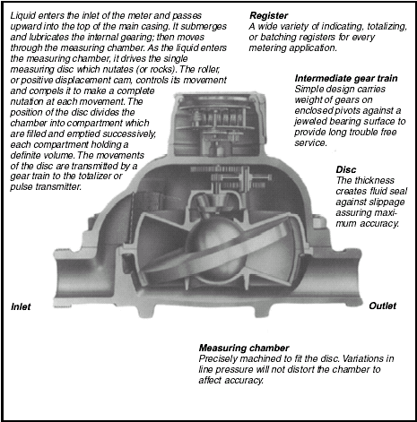
Figure 6.6: Inner workings of a nutating disc flowmeter. Source: http://www.aaliant.com/pdfs/M110.pdf

6.2.1.2 Magnetic Flowmeter
Magnetic flowmeters are volumetric, liquid flow measuring devices. They require low maintenance because they have no moving parts. Magnetic flowmeters also have high accuracy, analog outputs, and are insensitive to specific gravity, viscosity, pressure and temperature. Two basic styles of magnetic flowmeter are: 1) Wafer-style, which are capable of high accuracy measurements (Figure 6.7); and 2) Insertion-style, for greater economy and for larger pipe sizes (Figure 6.8).

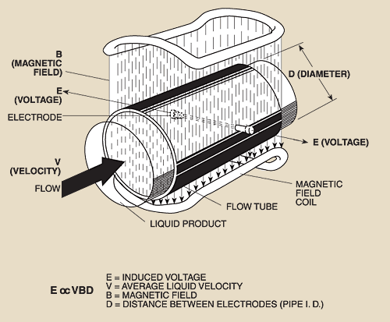
Figure 6.7: Wafer style magnetic flowmeter. Source: http://www.omega.com/prodinfo/magmeter.html

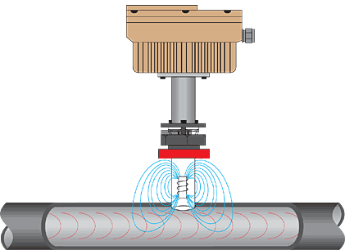
Figure 6.8: Insertion style magnetic flowmeter. Source: http://www.omega.com/prodinfo/magmeter.html

The operation of a magnetic flowmeter is based upon Faraday’s Law, which states that the voltage induced across any conductor as it moves at right angles through a magnetic field is proportional to the velocity of that conductor. Faraday’s Formula is as follows:
E α $V⋅B⋅D$ (6.2)
Where E is the voltage generated in a conductor, V is the velocity of the conductor (m/s), B is the magnetic field strength (Teslas), and D is the length of the conductor (m). To apply this principle to flow measurement with a magnetic flowmeter, the fluid must be electrically conductive. The voltage from the flowmeter changes as the velocity of the water within the pipe changes. This voltage change is recorded and can be related to the velocity of the water. When the pipe is flowing full the internal cross sectional area of the pipe is known and a flow rate can be determined. It is important to note that like the nutating disc that the pipe should be flowing full for the magnetic flowmeter to work properly. The magnetic flowmeter should also be installed in a low section of pipe, or U-trap that will always be full of water. Magnetic flowmeters range from approximately $700 to $2000 depending on manufacturer and model.

6.2.1.3 Doppler Sensor
The Doppler flowmeter uses a technology that is similar to the ultrasonic flowmeters mentioned earlier for open channel applications. The basic principle of operation employs the frequency shift, or Doppler Effect, of an ultrasonic signal when it is reflected by suspended particles or gas bubbles in motion. This means that Doppler meters continuously transmit high frequency sound that travels through the pipe wall and into the flowing liquid. Sound is reflected back to the sensor from solids or bubbles in the fluid. If the fluid is in motion, the echoes return at an altered frequency proportional to flow velocity. Doppler flow meters continuously measure this frequency shift to calculate flow velocity. The application of a Doppler sensor is illustrated in Figure 6.9.

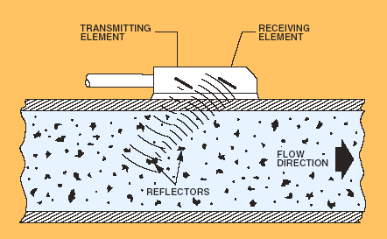
Figure 6.9: Example of a Doppler Sensor for measurement of flow velocity. Source: http://www.omega.com/toc_asp/frameset.html?book=Green&file=ultrasonic_flow_ref

A typical system incorporates a transmitter, indicator, totalizer, and transducer. The transducer is mounted on the exterior of the pipe and generates an ultrasonic signal which is transmitted through the wall of the pipe into the flowing liquid. It is driven by a high frequency oscillator in the transmitter through an interconnecting cable. The transmitter measures the difference between its output and input frequencies and converts this difference into a voltage or current output signal. Additionally, the signals are scaled and totalized to provide flow quantity. The transmitter frequency power and transducer configuration are selected to accommodate a wide variety of pipe sizes.

The Doppler sensor’s application is similar to that of the magnetic flowmeter, but operates on a different principle. Prices for Doppler sensors range from approximately $400 to $1500 depending on manufacturer, model, and accessories.

6.2.2 Collection Methods
The collection method is the most commonly used green roof stormwater runoff monitoring method in Europe and has been used for several years (Breuning 2005). This technique uses a tank or a cistern to collect the stormwater runoff from a green roof to a central location. After the water is collected in the tank it can be monitored for volume and flow rate. By knowing the cross sectional area of the tank and the rate at which the water in the tank is rising one can determine the flow rate of the stormwater discharge from the green roof. This method is demonstrated in the sample calculation below:
Tank Diameter = 6.00’ Tank Cross Sectional Area = πr² = 28.26 sf
Water Level Increase = 1” in 1 hour
Volume = $\text{28}\text{.}\text{26}\text{sf}×1\text{\} wideslash \{}12=2\text{.}\text{36}\text{cf}$
Flow Rate = $\frac{2\text{.}\text{36}\text{cf}}{1\text{hour}}×\frac{7\text{.}\text{48}\text{gal}}{1\text{cf}}×\frac{1\text{hour}}{\text{60}\text{min}}=0\text{.}\text{29}\text{gpm}$
The main advantage of the collection method is that it is very reliable since all the water is collected in one place to be monitored. The disadvantages for the collection method are due to same aspects that make it so reliable. Since the water is collected in a tank or system of tanks there must be space near the green roof for these tanks. Also, if one wants to monitor a large area of a green roof then the tanks need to be very large to have the capacity to hold the stormwater runoff. The tanks must also be equipped with an overflow or bypass to allow water to drain from or around the tanks in large storm events so the green roof will not become inundated. These tanks must also be drained periodically to prevent them from overflowing. Unless the tanks are equipped with an automated system to release water they will require a person to drain them manually. The only alternative to manually draining the tanks would be to install remote controlled or pressure controlled drains. These systems add another level of complexity, cost, and possibility of malfunction to the monitoring system. This defeats the low maintenance aspect of green roofs and is not desirable; however it is still a very effective and reliable method which is an option. There are a few choices for sensors that can be used in conjunction with the collection method.

6.2.2.1 Cistern / Tank Level Sensors
The cistern or tank method is the most commonly used way to collect stormwater runoff from a green roof. This method requires the water from the green roof to be piped into one or several large tanks to be collected. While the water is being collected the flow rate and volume can be monitored with the use of sensors. These sensors are discussed in detail in the following sections.

6.2.2.1.1 Pressure Probe / Transducer
The pressure probe sensor was mentioned earlier in Section 6.1.2 for use with an open channel monitoring system. While it may be unsuitable for some open channel applications it is very well designed for use with a cistern collection system. A pressure probe sensor usually needs a minimum water level to perform accurately, and this can be maintained with the water level inside a tank.

There are also sensors similar to the pressure probe which are called pressure transducers. These sensors work on the same basic principle. The transducer contains a pressure diaphragm which deforms when put under stress. A strain gauge is mounted to the pressure responsive diaphragm and measures the deformation. The strain gauge produces a signal that can be related to a pressure, which can then be related to the depth of water above the sensor. Pressure transducers can range in price anywhere from $60 to over $900 depending on the manufacturer, material, and accuracy desired. Examples of pressure transducers are shown in Figure 6.10.
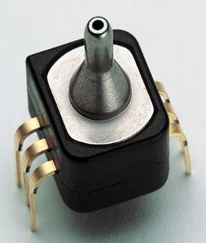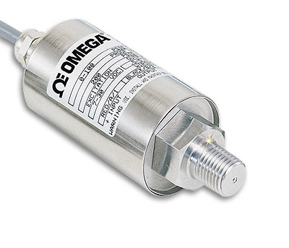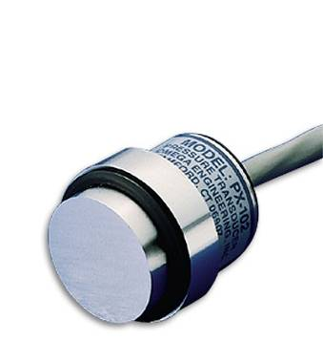
Figure 6.10: Examples of pressure transducers. Source: http://www.omega.com/prodinfo/pressuretransducers.html

6.2.2.1.2 Magnetic Float Gauge
Using a magnetic float gauge is another way to monitor the water level within a cistern or tank. Magnetic float gauges are made specifically for determining the water level within a tank and are very simple to use. The way a magnetic float gauge works is illustrated in Figure 6.11 from, Cesare Bonetti, Inc., a manufacturer of magnetic float gauges. The cylindrical magnet "A" in the float is able to turn horizontally on the axis "B" like a compass needle, so that magnetic force is always free to orient the magnet towards the magnetic scale. This magnetic scale contains small cylinders "C", rotating vertically on their axis "D", which contain smaller cylindrical magnets. Cylinders 1 and 2 as well 4 and 5 are in stable position, because their magnetic poles are oriented "N-S-N-S"; Cylinder 3 is not in a stable position because the north pole of the bigger magnet "A" attracts the south pole of the magnet within Cylinder 3. The same cylinder tries to rotate clockwise because its north pole would reach the south pole of Cylinder 2. As the increasing fluid level raises the float, the float magnet will approach Cylinder 4, attracting its south pole. After clockwise rotation, the float magnet will be in the same position as Cylinder 3. Cylinder 3 will be free to complete clockwise rotation, and its position will become stable with Cylinder 1 and 2. This process continues as the liquid level rises and the inverse occurs when the liquid level decreases. If the initial position of the float is known one can determine the water level increase from the difference between the final and initial position of the float. Some examples of magnetic float gauges are shown in Figure 6.12.

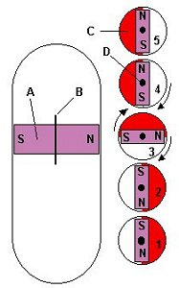
Figure 6.11: Illustration of magnetic float gauge.
Source: http://www.cesare-bonetti.it/Products/Level/magne01.html

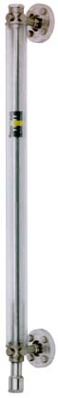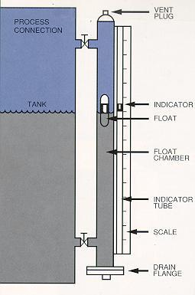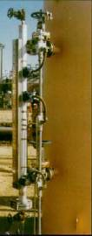
Figure 6.12: Examples of magnetic float gauges. Source: http://www.iprocessmart.com/Babbitt/liquid_level_gage.htm

6.2.2.1.3 Physical Gauge
The physical gauge is by far the most simple of all the sensors for the cistern or tank method. A physical gauge consists of graduated markings placed on the side of the tank. This can be as simple as attaching a yard or meter stick to the side of the tank in order to read the water level inside the tank. A physical gauge is the most inexpensive and simplest sensor since it does not require any power or have any moving parts that require maintenance or repair. However because of its design, it is extremely limited in its sensing capabilities. In order receive accurate results someone would have to watch and record the water level must be observed and recorded manually at timed intervals during storm events. Because of this the physical gauge may not be applicable in certain situations where people are not available to monitor the water collection tanks.

6.2.2.2 Bucket and Stopwatch
The bucket and stopwatch method is a variation on the cistern or tank method. For this method the water within the sampling area would be gathered to one location. This could be done by a gutter system with downspouts, roof curbing, and/or with roof drains and pipes. A discharge from the drainage system would be installed so the flow could be diverted into a container of known volume. The time it takes to fill the container is recorded. By using a predetermined volume and recording the time interval the flow rate of the water can be determined. This method is really only applicable for periodic sampling and cannot be used for continuous monitoring. Also, the monitoring area will have to be small enough to employ the bucket and stopwatch method.

6.2.2.3 Tipping Bucket
The use of a tipping bucket rain gauge is a variation of the bucket and stopwatch method that is more applicable to continuous monitoring. How a tipping bucket rain gauge functions is described in Section 9.1. The stormwater runoff from the green roof would be conveyed through a tipping bucket rain gauge to determine the flow rate and volume of runoff. One weakness of the tipping bucket rain gauge is that it can become inundated if the outflow from the green roof is very large. Thus, this approach will be applicable only to small monitoring areas from which low flows are yielded. A separate tipping bucket rain gauge could also be used to determine the amount of incipient rainfall on the roof (see Section 9.1). Tipping bucket rain gauges range from approximately $40 to $400. A tipping bucket rain gauge is illustrated in Figure 9.1.

7. SHALLOW-SLOPE ROOF MONITORING METHODS
The monitoring methods and sensors available for monitoring stormwater runoff from shallow sloped green roofs are the same as those used for flat green roofs. However, the methods application and installation of these methods differ somewhat from the methods employed for flat roofs.

7.1 Open Channel Monitoring
There are several ways to conduct open channel monitoring on a shallow-sloped green roof. The first method, which involves directing water through a flume placed on the roof’s surface, is very similar to the approach used for flat roofs. When the roof is sloped it is necessary to elevate the flume’s discharge end to make the flume level. This is illustrated in Figure 7.1 and Figure 7.2.

Roof Surface
FLUME
Gutter
Figure 7.1: Cross section of flume on roof monitoring system for a shallow-slope roof
(flume must be level)

GUTTER
GUTTER
FLUME
(Must Be Level)
PARTITIONING
Figure 7.2: Plan view of flume on roof monitoring system for a shallow-slope roof

The second way to use an open channel to monitor a shallow-sloped green roof is to place the flume within a gutter. If a flume is placed in a gutter just before the downspout and leveled then the water from the roof will be directed through the flume. A roof section with only one downspout will not require any partitioning with this approach. If there are more downspouts then the roof and gutter may need to be partitioned or multiple flumes may be necessary. This type of system is illustrated in Figure 7.3.

GUTTER
FLUME
Downspout
Roof Surface
Figure 7.3: Plan view of flume in gutter monitoring system for a shallow-slope roof

The third way to use a flume to monitor a shallow-sloped green roof is to place the flume on the ground and convey the water through the downspout and then through the flume. This could make the installation and leveling of the flume simpler and also facilitate access to monitoring equipment. This system is illustrated in Figure 7.4.

FLUME
Downspout
Figure 7.4: Downspout to flume monitoring system for shallow-slope roofs

Although the open channel monitoring systems for shallow-sloped green roofs are applied differently than those for a flat roof, all the sensors mentioned in Section 6.1 are still appropriate for these applications.

7.2 Closed Pipe Monitoring
Just as in flat roof monitoring there are two types of closed pipe monitoring methods for shallow-slope green roofs: inline and collection. Since most sloped roofs have a gutter and downspout system it is easiest to use these systems for the gathering of water to one point, whether it is just through the downspout, or to a tank for collection.

7.2.1 Inline Monitoring for Shallow-Slope Roofs
Since a gutter is usually present on a shallow-slope roof it is easiest to use this to collect the stormwater runoff. From the gutter the water will flow through a downspout. If there is more than one downspout for a given gutter then the roof and gutter should be partitioned or multiple monitoring systems should be considered. Inline monitoring is performed while the water is in the downspout. Most downspouts for gutters are made of rectangular, thin-wall metal of aluminum or copper. The inline flow sensors can’t be used directly in this type of piping, but adaptors that allow the water to flow from the rectangular downspout to a circular pipe are widely available. After the downspout is converted into a circular pipe the flow sensor can be installed. As mentioned previously (Section 6.2.1) it may be necessary to place some sensors in a low section of the pipe that always contains water, such as a trap. All of the inline flow sensors described in Section 6.2.1 are still appropriate for these applications. An example of an inline monitoring system is illustrated in Figure 7.5.

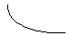
Downspout
Sensor
Adaptor
Trap
Figure 7.5: Inline downspout monitoring system for shallow-slope roofs

7.2.2 Collection Monitoring for Shallow-Slope Roofs
The collection monitoring system for shallow-slope green roofs works almost identically to that of a flat green roof. The only difference is that unlike a flat roof where the water enters through a roof drain and is then piped to a collection tank, the runoff from a shallow-slope roof is collected in a gutter and then the downspout is used to convey the water to a collection tank. Figure 7.6 contains an illustration of this method. All of the sensors used for a collection monitoring system described in Sections 6.2.2.1.1 through 6.2.2.1.3 are still appropriate for this application. The tank could also be replaced with a tipping bucket rain gauge as mentioned in Section 6.2.2.2.1 or a bucket for use with a bucket a stopwatch method mentioned in Section 6.2.2.2.
Downspout
Tank
Figure 7.6: Collection monitoring system for shallow-sloped roofs

8. STEEP-SLOPE ROOF MONITORING METHODS
The monitoring methods and sensors available for monitoring stormwater runoff from steep sloped green roofs are the same as those used for shallow-slope green roofs. However, there is one restriction with the application and installation of the open channel method. The monitoring method of installing the flume on the surface of the roof is not recommended because of the difficulties connecting and leveling the flume and sensor equipment. All other monitoring systems are sensors mentioned previously for shallow-slope roofs in Section 7 are appropriate for the application on a steeply sloped green roof.

9. PRECIPITATION MONITORING
When monitoring green roofs for stormwater runoff it is important to know the duration and intensity of each storm event. There are two ways to monitor storm events: sensing equipment on the green roof and surrounding data collection stations. Installing sensing equipment on the green roof is the recommended method since it will give much more accurate site-specific information, than existing surrounding weather stations. Sensing equipment installed on the green roof will give data for the specific location of the roof and the rainfall could vary over even short distances to the nearest existing weather station. However, if the situation does not permit sensing equipment to be installed on the green roof, other sources of local rainfall data can be utilized as discussed below in Section 9.2.

9.1 Sensing Technology
The most common and accurate rain gauge is a tipping bucket rain gauge. How a tipping bucket rain gauge works is indicated by its name. Two specially designed buckets tip when the weight of 0.01 inches of rain falls into them. When one bucket tips, the other bucket quickly moves into place to catch the rain. Each time a bucket tips, an electronic signal is sent to a recorder. To calculate the rainfall for a certain time period the number of marks on the recorder is simply multiplied by 0.01 inches. If the recorder is equipped with a clock, one can determine how much rain fell during a certain time period. The tipping bucket rain gauge shown in Figure 9.1 is a model that costs approximately $400, but there are many retailers which offer models for around $50. The relatively low cost of a rain gauge is well worth the investment in order to obtain rainfall data for the specific location of the green roof.

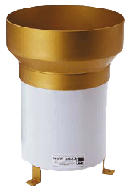
Figure 9.1: Tipping bucket rain gauge. Source: http://www.globalw.com/products/rg600.html

9.2 Available Precipitation Data Resources
If a particular situation does not allow for the use of rain gauge on the roof or in the nearby surrounding area there are some public resources of rainfall data available for Western Pennsylvania. The first of these resources is provided by the National Weather Service and lists the rainfall data for the last 24 hours. This source organizes the data by region, county, and city and covers Western Pennsylvania and Eastern Ohio. The link for this data is as follows: http://www.erh.noaa.gov/pbz/PITRVAPIT. For other locations within the United States precipitation information can be found at http://www.nws.noaa.gov/.

Another source for rainfall data in Pennsylvania is provided by the U.S. Geological Survey and rainfall history is broken down by county. Departures from normal rainfall amounts can also be viewed from this source. The link for this data is as follows: http://pa.water.usgs.gov/monitor/all_precip2.php

10. CASE STUDY: HAMERSCHLAG HALL, CARNEGIE MELLON UNIVERSITY

Green roofs are being investigated for use in reducing urban stormwater runoff flows in Pittsburgh and the surrounding region. Through funding from 3 Rivers Wet Weather, Inc. and the Pennsylvania Department of Environmental Protection a green roof demonstration project was constructed on Hamerschlag Hall at Carnegie Mellon University in May 2005. The green roof is located on the flat roof south of the main entrance to Hamerschlag Hall (HH) as shown in Figure 10.1. The HH green roof has been instrumented for monitoring and assessment of roof performance with respect to modifications of roof runoff flows as well as insulation properties (energy efficiency and performance).
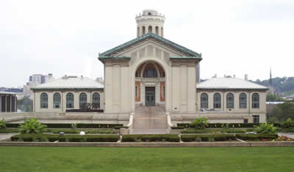
Green Roof Location
Figure 10.1: Green roof location on Hamerschlag Hall, Carnegie Mellon University

10.1 Green Roof Description
The HH roof is approximately 150 feet long and 30 feet wide with five roof drains located along the south side of the roof, as shown in Figures 10.2 and 10.3. The 4500 square foot roof was partitioned so two areas could be used for monitoring the stormwater runoff. A control monitoring area was established on a nearby unvegetated flat roof of similar design to the HH roof.

= Roof Drain
= Partitions / Curbing
= Roof Drain w/ Flume
Plan View
= Green Roof Boundary
Green Roof
Control Roof
Water Monitoring Area
Water Monitoring Area
Water Monitoring Area
= Rain Gauge Location
= Downspout Locations
Figure 10.2: Plan view layout of Hamerschlag Hall green roof and control roof

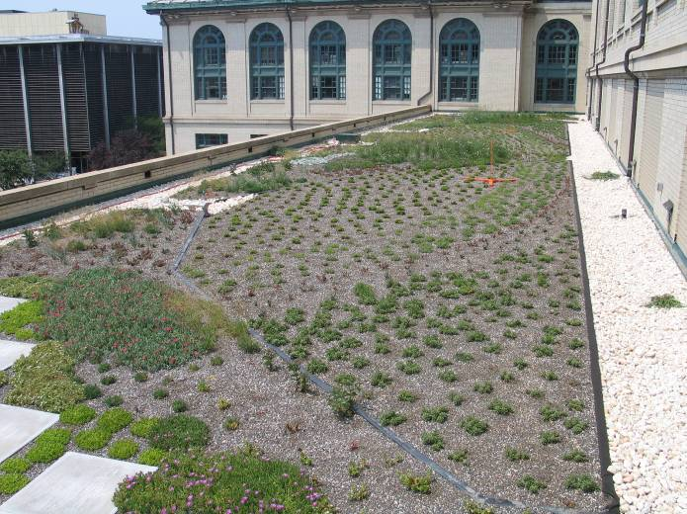
Figure 10.3: Picture of Hamerschlag Hall green roof

A cross section of the roof is illustrated in Figure 10.4. The growing medium varies in depth over the green roof from four to eight inches, but it is a constant four inches within the monitoring areas. Underneath the growing medium there is a geotextile barrier and then a 2” thick gravel drainage layer. A three ply impermeable roofing membrane is located under the drainage layer.
Impermeable Membrane
2” Gravel Drainage Layer
Geo-textile
4” Growing Medium Layer
Plant Layer
Figure 10.4: Hamerschlag Hall green roof cross section

Over 40 species of plants were installed in an arching rainbow arrangement across the roof. Plant species included a variety of hardy succulent plants such as sedum as well as native grasses. A picture of the completed green roof can be seen in Figure 10.3.

10.2 Green Roof Monitoring Areas
The unique features of the HH roof needed to be considered carefully in designing the water monitoring system for it. This was done through several meetings with the various parties involved in the project such as the roofing system provider, the roofing contractor, the campus project manager, the campus engineer, and the green roof monitoring research team of faculty and students. There were several constraints posed by the existing condition of the roof. The main constraint was the drainage from a sloped roof above the green roof. The downspouts from this roof discharged to the flat roof surface of the HH roof where the green roof was to be installed. The water would then travel across the roof and exit through the existing roof drains. Since it was desired to monitor the performance of the green roof only with respect to incipient rainfall, the influence of run-on from the upper roof needed to be eliminated.
It was determined that the green roof would consist of two water monitoring areas draining to two of the five drains on the flat roof thus leaving three roof drains for the drainage from the upper roof. Each monitoring area covers approximately 650 square feet of the green roofs surface, making the total monitored area 1300 square feet, or about 30% of the total area of the green roof. The dimensions of the green roof water monitoring area are shown in Figure 10.5.
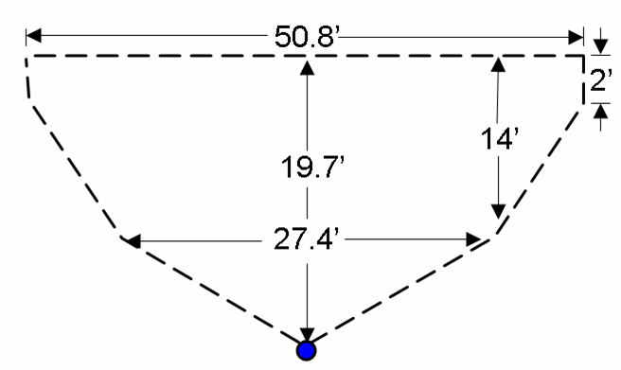
Figure 10.5: Dimensions of a Hamerschlag Hall green roof water monitoring area

The two monitoring areas are bounded by curbing made from galvanized sheet metal. This curbing is covered by a rubber membrane that is sealed to the upper membrane of the roof ensuring that only incipient rainfall is monitored via the flume located at the discharge point for each monitoring area (see Figure 10.6). The curbing directs the water within the monitoring area through the flume so the stormwater drainage can be measured.

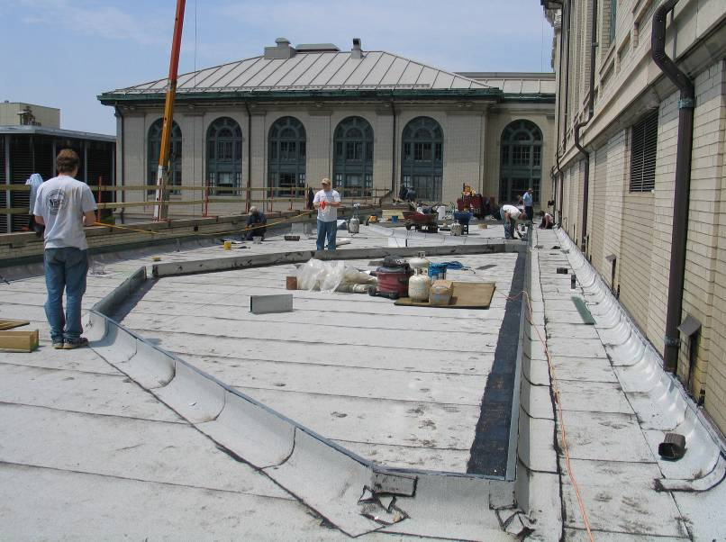
Figure 10.6: Curbing for monitoring areas on the Hamerschlag Hall south roof

The downspouts from the upper roof were piped around the monitoring areas toward the existing three roof drains by using corrugated black plastic pipe. The connection between the downspout and the pipe can be seen in Figure 10.7. The locations of the downspout pipes are illustrated in Figure 10.8.
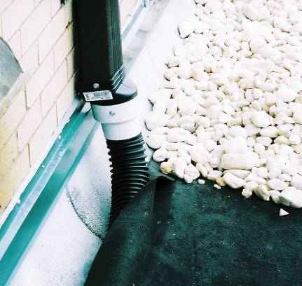
Figure 10.7: Piped downspout from upper roof onto the Hamerschlag Hall south roof

= Roof Drain
= Partitions / Curbing
= Roof Drain w/ Flume
Plan View
= Green Roof Boundary
Control Roof
Water Monitoring Area
Water Monitoring Area
Water Monitoring Area
= Rain Gauge Location
= Downspout Locations
Green Roof
= Downspout Pipe Locations
Figure 10.8: Downspout pipe locations on the Hamerschlag Hall south roof

Another special modification had to be made in the design of the two green roof monitoring areas in order to accommodate the flumes for water flow monitoring. Since the flumes have a two inch lip on their entrance and exit, the inside of the monitoring areas needed to be raised by two inches. Raising the monitoring area provided a smooth transition from the base of the monitoring area to the base of the flume. In collaboration with the roofing contractor it was decided that the monitoring areas would be raised by including an additional two inches of insulation within the green roof monitoring areas. A cross section of the HH green roof within the monitoring areas is illustrated in Figure 10.9.
Impermeable Membrane
2” Gravel Drainage Layer
Geo-textile
4” Growing Medium Layer
Plant Layer
2” Insulation Layer
Impermeable Membrane
Figure 10.9: Hamerschlag Hall green roof monitoring area cross section

10.3 Control Roof
In addition to the two monitoring areas on the HH green roof there is a control roof monitoring area on an adjacent building just south of the HH green roof. The control roof was also partitioned so only a portion if the roof would be monitored. The curbing used to partition the control roof consisted of 2-in. x 4-in. lumber, rubber membrane, and 2-in. x 4-in. galvanized steel C-channel. The 2-in. x 4-in. lumber was placed on its wide side on top of the existing roof membrane. The lumber was then covered with rubber membrane material and sealed to the roof surface. After the installation of this curbing it was decided that the curbing should be higher. Galvanized steel C-channel was then attached to the top of the lumber curbing with screws and roof caulking was used for a water tight seal. Figure 10.10 shows a picture showing the control roof curbing. The control monitoring area is approximately 710 square feet. A schematic of the control monitoring area can be seen in Figure 10.2.
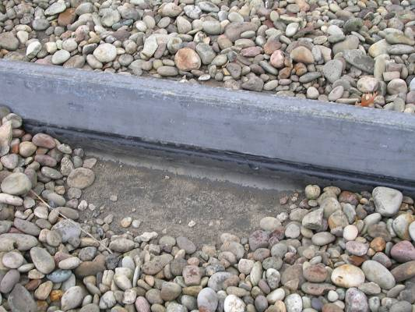
Figure 10.10: Control roof curbing: 2” x 4” board laid flat on existing roof surface, covered with rubber membrane material sealed to existing roof surface and with steel C-channel on top.

The two inch lip of the flume was also an issue that had to be addressed on the control roof. This roof was an existing rubber membrane roof and the flume had to be installed level with the roof surface. This was done by cutting into the roof membrane and removing the layer of insulation below it where the flume would be placed. The flume was then flashed into the roof membrane to ensure a watertight seal. A picture of the control roof flume is show in Figure 10.11.
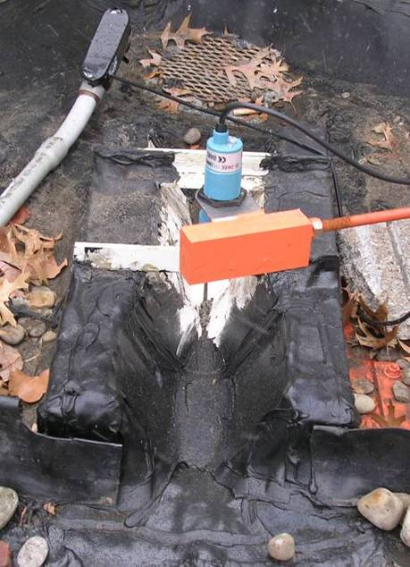
Figure 10.11: Control roof flume
10.4 Design of Green Roof Water Flow Monitoring System
An open channel flume monitoring system was chosen. A closed pipe system could not be used since the drainage pipes for the roof are inaccessible and located within the masonry walls of the building. A small, 60-degree, V trapezoidal Plasti-Fab (Tualatin, Oregon) flume with a flow range from 1 to 35 gallons per minute was the specific flume chosen. After choosing the flume a Stevens STR ultrasonic water level sensor from Fondriest Environmental was selected to monitor the level of water flowing through the flume. A picture of the installed system can be seen in Figure 10.12.
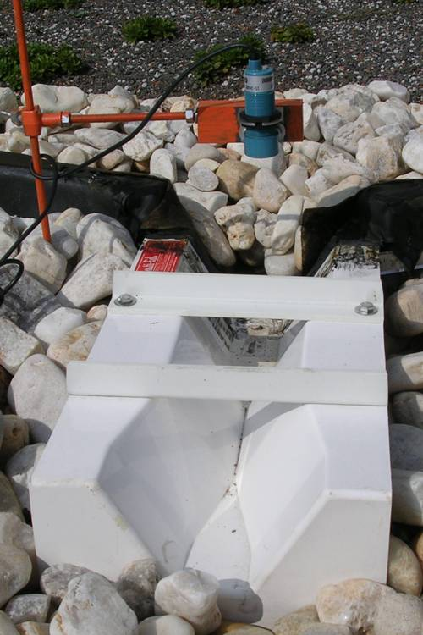
Figure 10.12: Plasti-Fab flume and Stevens Ultrasonic water level sensor

An RG600 tipping bucket rain gauge from Global Water (Gold River, CA) was chosen to collect precipitation data from the green roof site. The RG600 tipping bucket rain gauge was illustrated in Figure 9.1. The stand used to mount the rain gauge can be seen in Figure 10.13. In this photograph the rain gauge is not mounted, but mounts on the top of the pole shown in Figure 10.13. There are also other weather sensing instruments that are mounted on the same stand.
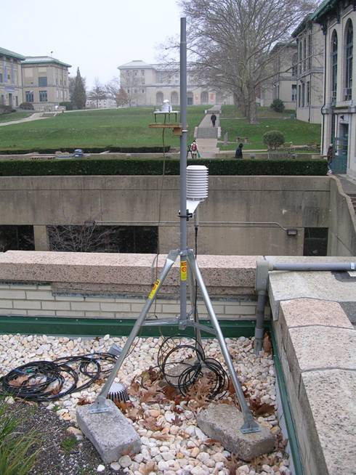
Figure 10.13: Rain gauge stand on Hamerschlag Hall green roof

The locations of the flumes and ultrasonic sensors as well as the rain gauge can be seen in Figure 10.2.

The particular location of the rain gauge was chosen because it is between the green roof and control roof, and it is located away from the surrounding buildings to reduce chance of precipitation obstruction. Prior to the installation of the green roof a rainfall distribution study was performed. This was done by placing numerous wide-mouth plastic bottles in locations spread out over the green roof and control roof. By observing the variation of precipitation collected within the bottles an assessment was made of how the surrounding area affects the precipitation distribution on the roof. The location in the south east corner of the HH green roof was determined to have the most representative samples for both the green roof and control roof.

10.5 Green Roof Monitoring Plan
Data collected from the sensors on the HH green roof and control roof are transmitted to a multi channel data logger which is located in an office below the HH green roof. The wires from the sensors are contained in 0.5-in. to 1-in. PVC conduit and are routed to a box which is flashed into the top membrane of the roof. The PVC conduit should be sized to allow space for wires from other sensors should they need to be added in the future. The PVC conduit also has access points at 90 degree bends to facilitate pulling wires in the future. The wire collection box is show in Figure 10.14.
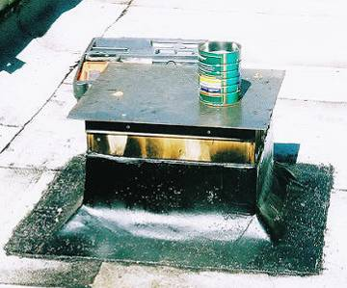
Figure 10.14: Hamerschlag Hall green roof sensor wire collection box. Note the flashing connection with the top membrane of the roof.

Located within this box is a three inch diameter hole that goes through the concrete roof deck into the ceiling of the office below. During construction a piece of PVC pipe was inserted into the hole to prevent water from entering through the hole. The interior of the wire collection box can be seen in Figure 10.15.
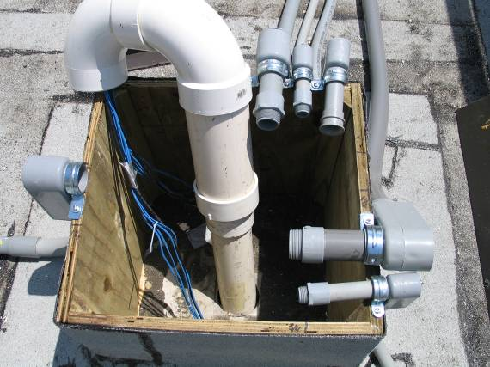
Figure 10.15: Interior of Hamerschlag Hall green roof sensor wire collection box

Also illustrated in Figure 10.15 is the PVC conduit that carries the sensor wires from various locations on the HH green roof and control roof into the box so they can then enter the office below. When construction was completed the PVC pipe was removed and a lid was attached to the top of the box. A picture of the completed wire collection box is shown in Figure 10.16.

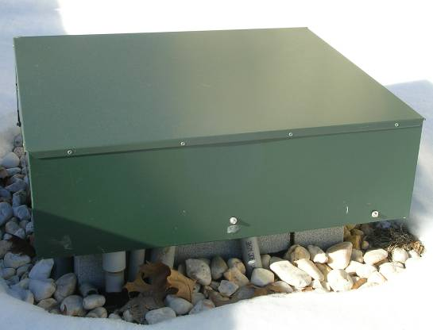
PVC Conduit
Figure 10.16: Completed wire collection box on Hamerschlag Hall green roof.

After the sensor wires come through the ceiling of the data collection office they are connected to a multi channel data logger. The data logger that was selected for use with the HH green roof is the National Instruments (Austin, TX) FieldPoint system which can be seen in Figure 10.16.
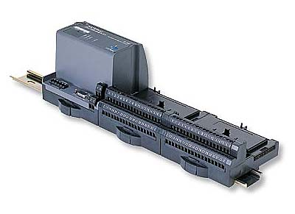
Power Supply
Base
Figure 10.17: National Instruments FieldPoint data logger. Source: http://sine.ni.com/nips/cds/view/p/lang/en/nid/2178

The FieldPoint system was chosen because of its flexibility and multiple channels. Since the data logger needed to be used to collect data from the ultrasonic flume sensors, tipping bucket rain gauge, temperature and heat flux sensors, as well as other sensing equipment multiple channels were required. The FieldPoint system has the ability to add bases and modules to increase the number of channels depending on the number of sensors that are collecting data. The field point system is also able to collect data from sensors with different types of outputs, such as voltage or current. The power supply provides power to the data logger as well as to low power sensors such as the ultrasonic flume sensors. An additional power supply was needed to power the tipping bucket rain gauge.

The data logger is connected to a computer where National Instruments LabView software is used to organize and interpret the data from the sensors. The LabView software allows the sampling frequency to vary on each sensor. It also can convert the data from the sensors into more meaningful data. For example it can take the current signal from an ultrasonic sensor, convert it into a water level through the equation for the sensor, which is then converted into a flow rate using the equation for the flume. The flow rate can then be recorded over time and stored on the computer. Using the data logger allows the roof to be monitored continuously and the data from each sensor to be organized. The LabView software can also be used to filter extraneous data that is gathered when the flumes are dry and when it is not raining.

11. GREEN ROOF WATER BALANCE MODEL
Assessment of green roof performance with respect to stormwater retention can be conducted by means of water balance analysis. A water balance model for green roofs was developed to be used as a tool for interpreting stormwater inflow and outflow data for a particular roof; and to be able to describe water retention performance for a particular roof; and to be able to develop an empirical database for green roof performance. Through application of the model to a large number of storm events for a particular green roof, and eventually to data for a large number of green roofs, average model parameters will be developed that will provide the ability to predict green roof performance given green roof characteristics/properties and rainfall data.

11.1 Water Balance Approach
The green roof water balance model is based on the principal of mass balance. The first step when performing a mass balance is to define system boundaries. Once system boundaries are defined mass flows entering, exiting, or accumulating within the system must be identified. In the case of a green roof the system is the monitored area and the roof partitions are the system boundaries. The incoming rainfall enters the system, the stormwater discharge exits the system, and the difference is either retained within the system, or is lost through evaporation/ evapotranspiration. Figure 11.1 shows a diagram of a green roof mass balance. Q_{in} represents the rainfall inflow, Q_{out} represents the green roof water outflow, Q_{accum} represents the stormwater accumulation rate, and Q_{evap} represents the water that is evaporated or evapotranspired. The Q terms are volumetric flow rates (volume/time), which can be converted to mass flow rates by multiplying by the density of water.

Q_{in}
Q_{out}
Q_{evap}
Q_{accum}
Figure 11.1: Green roof mass balance diagram

The equation resulting from the mass balance can be expressed as:

$Q_{\text{out}}=Q_{\text{in}}−Q_{\text{evap}}−Q_{\text{accum}}$ (11.1)

Since it is difficult to measure the evaporation/evapotranspiration term and the retention term separately they can be combined into one aggregated “retention” term, Q_{ret}. If Q_{accum} and Q_{evap} are combined into Q_{ret} then Equation 11.1 can be rearranged and rewritten as:

$Q_{\text{ret}}=Q_{\text{in}}−Q_{\text{out}}$ (11.2)

By comparing inflow and outflow data from the green roof monitoring area the net retention of water by the green roof can be determined. It is this net retention that the water balance model is designed to evaluate and predict.
11.2 Empirical Water Balance Model for Green Roofs
For the water balance model to be useful for predicting green roof performance it is necessary to relate the retention data to the inflow data and key physical parameters of the green roof. These physical parameters include growing medium thickness, roof slope, plant density, and temperature. The equation relating these parameters to green roof retention is:

$Q_{\text{ret}}={αQ}_{\text{in}}+βZ+χS+δP+εT$ (11.3)

$Q_{\text{ret}}$ = Net retention rate for green roof in gallons per minute
$Q_{\text{in}}$ = Rain water inflow in gallons per minute
$Z$ = Growing medium thickness in inches
$S$ = Roof slope in percent
$P$ = Plant density in percent coverage of green roof area
$T$ = Temperature in degrees Fahrenheit
$α,β,χ,δ,ε$ = Empirical coefficients

There are other properties of green roofs and climate that will affect water retention performance, such as plant type, humidity, etc., but the parameters listed in Equation 11.3 are easily measured and representative of the physical, chemical, and biological mechanisms that will determine the system performance. Note that the monitoring area for the particular green roof is accounted for in the parameter Q_{in}, which is the product of rainfall intensity (at time t) and the green roof area.

11.3 Example Applications of Empirical Water Balance Model
For the purposes of illustrating the water balance model, hypothetical rainfall inflow and outflow data were synthesized. The inflow and outflow data can be seen in Table 11.1. The inflow and outflow data are graphed in Figure 11.2.

Table 11.1: Hypothetical Inflow and outflow data for water balance model example application

Time (min) | Inflow (gpm) | Outflow (gpm)
0 | 0.00 | 0.00
30 | 2.19 | 0.00
60 | 3.83 | 0.00
90 | 4.38 | 0.00
120 | 3.28 | 0.00
150 | 1.64 | 0.55
180 | 0.55 | 0.96
210 | 0.22 | 1.09
240 | 0.11 | 0.82
270 | 0.02 | 0.41
300 | 0.02 | 0.14
330 | 0.01 | 0.05
360 | 0.00 | 0.03
390 | 0.00 | 0.01
420 | 0.00 | 0.00
450 | 0.00 | 0.00

Figure 11.2: Hypothetical inflow and outflow data for water balance model example application
For monitored green roofs, the inflow can be calculated by multiplying the rainfall rate (e.g., inches/minute) at a particular time by the area of the monitoring area. The outflow data will be observed directly from the outflow sensor on the monitoring area. The water that is “retained” (accumulated and evaporated/evapotranspired) within the monitored area of the green roof can be determined by taking the difference between the inflow and outflow. The net retention data from the synthesized inflow and outflow data are shown in Table 11.2. Figure 11.3 shows the net retention data plotted with the inflow and outflow.

The time-dependant Q_{ret} data obtained for a particular green roof can be fitted to Equation 11.3, and the values of the empirical coefficients can be determined for each time. If this procedure is done for a number of different storm events, average values of the empirical coefficients can be determined for particular times after the initiation of the rainfall event. These values would only be applicable to the particular roof, but may be extendable to roofs of similar design and size. This will require data collection and modeling for several roofs of similar design.

Table 11.2: Green roof water retention data for water balance model example application

Time (min) | Net Retention (Inflow - Outflow) (gpm)
0 | 0.00
30 | 2.19
60 | 3.83
90 | 4.38
120 | 3.28
150 | 1.09
180 | -0.41
210 | -0.88
240 | -0.71
270 | -0.39
300 | -0.12
330 | -0.04
360 | -0.03
390 | -0.01
420 | 0.00
450 | 0.00

Figure 11.3: Net retention data with inflow and outflow data for water balance model example application

To determine the volume of inflow, outflow and retention the graphs shown in Figure 11.5 can be integrated and the area under the graph is equal the volume in gallons. The integrated values of the inflow, outflow, and retention hydrographs are shown in Table 11.3.

Table 11.3: Integrated volumes for inflow, outflow, and retention for example application

Time (min) | Inflow Volume (gal) | Outflow Volume (gal) | Retained Volume (gal)
0 | 0.00 | 0.00 | 0.00
30 | 32.82 | 0.00 | 32.82
60 | 90.25 | 0.00 | 90.25
90 | 123.07 | 0.00 | 123.07
120 | 114.86 | 0.00 | 114.86
150 | 73.84 | 8.20 | 65.64
180 | 32.82 | 22.56 | 10.26
210 | 11.49 | 30.77 | -19.28
240 | 4.92 | 28.72 | -23.79
270 | 1.97 | 18.46 | -16.49
300 | 0.57 | 8.20 | -7.63
330 | 0.41 | 2.87 | -2.46
360 | 0.16 | 1.23 | -1.07
390 | 0.00 | 0.49 | -0.49
420 | 0.00 | 0.14 | -0.14
450 | 0.00 | 0.10 | -0.10
Total | 487.19 | 121.76 | 365.43

Through the use of the Excel solver feature and the time dependent retention data results can be determined for , and . The results are shown in Table 11.4 for the example application. These results are graphed in Figure 11.4. A polynomial or other type of empirical curve fitting equation could be used to describe the coefficient values shown in Figure 11.4. Such equations could be used to determine the value for each coefficient at any specific time in order to predict the water retention hydrograph for a given green roof.

Table 11.4: Empirical retention coefficient data for the water balance model example application

Time | Alpha | Beta | Chi | Delta | Epsilon | Retention Rate (gpm)
0 | 0.00000 | 0.00000 | 0.00000 | 0.00000 | 0.00000 | 0.00
30 | 0.00031 | 0.00114 | 0.00019 | 0.01620 | 0.01239 | 2.19
60 | 0.00054 | 0.00200 | 0.00033 | 0.02833 | 0.02167 | 3.83
90 | 0.00062 | 0.00229 | 0.00038 | 0.03240 | 0.02478 | 4.38
120 | 0.00046 | 0.00171 | 0.00029 | 0.02427 | 0.01856 | 3.28
150 | 0.00015 | 0.00057 | 0.00009 | 0.00806 | 0.00617 | 1.09
180 | -0.00006 | -0.00021 | -0.00004 | -0.00303 | -0.00232 | -0.41
210 | -0.00012 | -0.00046 | -0.00008 | -0.00651 | -0.00498 | -0.88
240 | -0.00010 | -0.00037 | -0.00006 | -0.00525 | -0.00402 | -0.71
270 | -0.00006 | -0.00020 | -0.00003 | -0.00289 | -0.00221 | -0.39
300 | -0.00002 | -0.00006 | -0.00001 | -0.00089 | -0.00068 | -0.12
330 | -0.00001 | -0.00002 | 0.00000 | -0.00030 | -0.00023 | -0.04
360 | 0.00000 | -0.00002 | 0.00000 | -0.00022 | -0.00017 | -0.03
390 | 0.00000 | -0.00001 | 0.00000 | -0.00007 | -0.00006 | -0.01
420 | 0.00000 | 0.00000 | 0.00000 | 0.00000 | 0.00000 | 0.00
450 | 0.00000 | 0.00000 | 0.00000 | 0.00000 | 0.00000 | 0.00

Roof and environmental properties: Soil thickness = 6 inches, Roof slope = 1%, Plant density = 85%, and Temperature = 65º F

Figure 11.4: Empirical retention coefficient results for the water balance model example application

11.4 Local and General Applications of the Model
For local applications the green roof water balance model can be simplified. Since some of the physical parameters of a particular roof will never change (growing medium thickness and roof slope) they can be eliminated from the empirical retention Equation (11.3). The simplified equation is:
$Q_{\text{accum}}={αQ}_{\text{in}}+δP+εT$ (11.4)

Through the use of the Excel solver feature and the time dependent retention data results can be determined for $α,δ$, and . The results are shown in Table 11.5 for the example application. These results are graphed in Figure 11.5.

Table 11.5: Empirical retention coefficient data for the simplified water balance model example application

Time | Alpha | Delta | Epsilon | Retention Rate (gpm)
0 | 0.00000 | 0.00000 | 0.00000 | 0.00
30 | 0.00031 | 0.01625 | 0.01243 | 2.19
60 | 0.00054 | 0.02843 | 0.02174 | 3.83
90 | 0.00062 | 0.03251 | 0.02486 | 4.38
120 | 0.00046 | 0.02434 | 0.01862 | 3.28
150 | 0.00015 | 0.00809 | 0.00619 | 1.09
180 | -0.00006 | -0.00304 | -0.00233 | -0.41
210 | -0.00012 | -0.00653 | -0.00499 | -0.88
240 | -0.00010 | -0.00527 | -0.00403 | -0.71
270 | -0.00006 | -0.00289 | -0.00221 | -0.39
300 | -0.00002 | -0.00089 | -0.00068 | -0.12
330 | -0.00001 | -0.00030 | -0.00023 | -0.04
360 | 0.00000 | -0.00022 | -0.00017 | -0.03
390 | 0.00000 | -0.00007 | -0.00006 | -0.01
420 | 0.00000 | 0.00000 | 0.00000 | 0.00
450 | 0.00000 | 0.00000 | 0.00000 | 0.00

Roof and environmental properties: Plant density = 85% and Temperature = 65º F

Figure 11.5: Empirical retention coefficient results for the simplified water balance model example application

Initially, with limited results the green roof water balance model will only be useful for application to green roofs with certain characteristics in certain locations. For the green roof water balance model to apply globally, a database must be compiled with results from multiple green roofs of different types in different locations. Once a database is created the coefficient values can be compared for similar green roofs for specific time points and storm intensities. By comparing these values a global green roof water balance model database may be possible that will be able to predict green roof water retention rates and volumes regardless of type or location.
12. REFERENCES
Breuning, Jörg (2005), Green Roof Service LLC 3410, Ady Road, Street, MD 21154-1606

DeNardo, J.C., Jarrett, A.R., Manbeck, H.B., Beattie, D.J., Berghage, R.D. (2003), “Stormwater Detention and Retention Abilities of Green Roofs” in World Water & Environmental Resources Congress, Philadelphia, June 23-26, 2003

Herman, R. (2003), “Green Roofs in Germany: Yesterday, Today, and Tomorrow,” in Proceedings of the Conference on Greening Rooftops for Sustainable Communities, Chicago, May 29-30.

Hutchinson, D., Abrams, P., Retzlaff, R., Liptan, T. (2003), “Stormwater Monitoring Two Ecoroofs in Portland, Oregon, USA,” in Proceedings of the Conference on Greening Rooftops for Sustainable Communities, Chicago, May 29-30, Green Roofs for Healthy Cities, Toronto, Ontario, Canada.

Johnston, C., McCreary, K., Nelms, C. (2003), “Vancouver Public Library Green Roof Monitoring Project,” Kerr Wood Leidal Associated Ltd. Burnaby, B.C., Public Works and Government Services Canada, http://www.bluestem.ca/pdf/GreenRoofPaper_pdf.pdf, accessed June 20, 2005.

Lindhqvist, V. (2003), “Swedish Green Roof Initiative: The Green Roof Society, The International Green Roof Institute and Augustenborg’s Botanical Roof Garden,” in Proceedings of the Conference on Greening Rooftops for Sustainable Communities, Chicago, May 29-30.

Miller, C. (2005), “Extensive Green Roofs,” Roofscapes Inc., Philadelphia, PA http://www.wbdg.org/design/greenroofs.php, accessed December 18, 2005

Slone, D., Evans, D. (2003), “Integrating Green Roofs and Low Impact Design into Municipal Storm Water Regulations,” in Proceedings of the Conference on Greening Rooftops for Sustainable Communities, Chicago, May 29-30.

Worden, E., Guidry, D., Alonso Ng, A., Schore, A.(2004), “Green Roofs in Urban Landscapes” Fort Lauderdale Research and Education Center, University of Florida, Fort Lauderdale, Florida September, 2004. http://edis.ifas.ufl.edu/EP240 accessed September 9, 2005

